NAGOG WOODS COMMUNITY CORPORATION

VILLAGE OF NAGOG WOODS
ACTON, MASSACHUSETTS 01718
Office: (978) 263-4887 FAX :( 978) 263-8063

Village of Nagog Woods
Resident Handbook
2019

VILLAGE OF NAGOG WOODS
HANDBOOK FOR RESIDENTS

2017
Table of Contents

Page#
Table of Contents………………………………………………………………………………….2
Directory of Village Management, Emergency, Board Members, and Board of Managers….3-5
General Information……………………………………………………………………………….6-9
Common Fees/Pet…………………………………………………………………………………..10-12
Swimming Pool Rules………………………………………………………………………………12-14
Tennis Court Information………………………………………………………………………....14-15
Trash Rules………………………………………………………………………………………....15-16
Government and Management…………………………………………………………………....16-17
Maintenance Notes………………………………………………………………………………....17-18
Restrictions……………….…………………………………………………………………………18-21
Insurance……………………………………………………………………………………………20-21
Community Relations………………………………………………………………………………21-22
Parking Rules…………………………………………………………………………………….. .23-38
Clubhouse parking Policy for Winter and Form…...……………………………………………39-40
Satellite Antenna Standards………………………………………………………………………41-44
Snow Removal Rules………………………………………………………………………………45
Landscape Guidelines……………………………………………………………………………..46
Architectural Standards and Exterior Storage………………………………………………….47-53
Water Main Shut Off Locations………………………………………………………………….53-55
Handicapped Parking Standards………………………………………………………………...56
Responsibility Chart………………………………………………………………………………57
Map of Village……………………………………………………………………………………...59
Closing Documents Information………………………………………………………………….60
Policy for POD/Storage/Shipping Containers…………………………………………………...61
Emergency Notification Form………………………………………………………………….....62-63

NWCC BOARD OF DIRECTORS – March 29, 2018
Peter Rosner (President) & (Condo I)
Peter_Rosner@yahoo.com

Sarah Mlezia (Vice President)
smleziva7@gmail.com
Steve Noone (Treasurer)
stephenrnoone@gmail.com
Melissa Buono (Secretary)
mcjb2000@aol.com

Liz Reinhardt (Condo I)
ereinhardt@lizreinhardtlaw.com
Narci Woods (Condo II)
Narciwoods@gmail.com
Ellen Freshman (Condo II)
ejfreshman@aol.com

Bobby Wright (Condo III)
Bobbywright4u@gmail.com

Marcus Lewis (Condo III)
marcus@marcuslewisenterprises.com

Jennifer Gaeta (Condo IV)
Jenn.Gaeta@gmail.com

EQC MEMBERS – APRIL 7, 2017
Donna Schilling
dschilling15@verizon.net
Fran Busse
fran@bussestudio.com

ASSOCIATION OFFICERS – APRIL 16, 2018

CONDO I:
President: Liz Reinhardt
reinfamily@verizon.net
Vice President: Linda Noone
lfnoone@hotmail.com
Treasurer: Paul Raymond
Paul.raymond@gmail.com

CONDO II:
President: Claudia Abramson
the.abramsons@comcast.net
Vice President: Ellen Freshman
ejfreshman@aol.com
Treasurer: Michael Rheaume
MichaelRhe@aol.com
Secretary: Narci Woods
NarciWoods@gmail.com
Member-at-Large: Leon Mintz
leon.j.mintz@gmail.com

CONDO III:
President/Treasurer: Miles Fidelman
mfidelman@meetinghouse.net
Vice President: Bengt Muten
bengt@muten.com
Secretary: Donna Schilling
dschilling15@verizon.net
Member-at-Large: Andrew Roberts drew.roberts5922@gmail.com

CONDO IV:
President: Deb O’Hanlon
deb@debohanlon.com
Vice President: Monica Pilman
monicapilman@yahoo.com
Treasurer: Sarah Mleziva
smleziva7@gmail.com
Secretary: Paula Kwon
pkwo@aol.com
Member-at-Large: Brenda Ferriero
blzf@verizon.net

Village of Nagog Woods Website

www.villageofnagogwoods.com

The Dartmouth Group Staff

Nagog Woods Office Phone and Emergency Number: 978-263-4887
James Shope (Community Manager)
JShope@TheDartmouthGroup.com

Tyler Osborn (Assistant Community Manager)
Tosborn@TheDartmouthGroup.com

TDG Maintenance Team 978-263-4887

Maintenance Staff
Kirk Geddes
Tim Hulings
Chris Orton
Cody Curtis

GENERAL INFORMATION AND PROCEDURES

NAGOG WOODS COMMUNITY CORPORATION OFFICE
The office is located upstairs in the Clubhouse and is open Monday through Friday, 7:30 a.m. to 4:00 p.m. After office hours, in the case of an emergency, an answering service may be used to reach maintenance personnel 24 hours a day.

OUTSIDE CONTRACTORS
A key to your unit may be left at the office to give to a service company. Permission must be given before the company may enter your unit and for a key to be released. Please understand that Nagog Wood Management Office does not give out recommendations for contractors. Unit owners should pick the contractor that does work at their unit. Below are names of contractors who have done work in the Village. Some residents like to hire contractors that have done work in the Village. Residents should make sure that contractors are insured.
A few service companies are:

Fiberglass Tub Refurbishment Bath Genie 800-255-8827
Plumbing Kelleher 978-263-3356
Heat and Air Conditioning Manny Chaves 978-562-5309
New England Appliances Ron 978-263-1191
Electrician Watjus Electric 978-897-7366
Cleaning Warilas 978-448-9348

MAIL
We have our own Postal Kiosk in the Village and our own zip code is 01718. The Acton Post Office delivers the mail to the Village. If you plan to go out of town, please notify the Town of Acton Post Office at 978-263-7744. The Village of Nagog Woods does not handle any postal services (packages, new/old key, and mail delivery, etc). The main Post Office is located off of Route 27 heading toward the center of town.

The “Village Only” slot may also be used, postage free, to mail your correspondence with the Village office and Board of Directors only. It may not be used to mail correspondence between residents within the Village-such mail must have proper postage.

NEWSLETTER
A newsletter, called the “Friday Flyer” is distributed each Friday. Friday flyers are placed in each of the three plastic containers at the Postal Kiosk. Residents may receive the flyer via email or pick one up at the Postal Kiosk. Residents can request to have it sent via email.
The Friday Flyer is also posted on SenEarthCo. This is the primary form of communication between the Nagog Woods Office/Board of Directors and residents. Please read it weekly so you do not miss important information.

RIGHT OF ACCESS
As provided by the by-laws, in the case of an emergency, the Village Manager or any other person authorized by the Board of Directors shall have the right of immediate entry whether or not the unit owner is present at the time. In the event of a dire emergency (such as a fire), a unit which cannot otherwise be entered will be entered by breaking a door or window at the unit owner’s expense.

SECURITY
There is a lockbox in the Village office for storing keys of units that are not on the Master Key system. Keys are coded and a list of codes and unit numbers are maintained separately for security reasons. Should you install a dead bolt lock, the office should be notified as to how the unit should be entered in an emergency. If service repairmen are to enter you unit a key must be left at the office, master keys will not be released nor will maintenance staff accompany repairmen to your unit.

Always lock doors and windows when leaving your unit. Metal rods placed in the door and window frames will provide some degree of protection and some peace of mind. Alternatives to metal rods are wood dowels, which can be placed in the groove of the fixed side of a sliding door or window when it is closed and locked. Sliding doors may also have a lock or screws on the top track to prevent the door from being lifted up and out.

Vehicles should always be locked with windows in the up position. Items of value should not be left in plain sight.

Residents should remember to call the office if they are expecting guest(s) at their unit (cab, family, contractors) who may call the office for directions or resident information. The office will not give out street addresses or any identifying unit information to people that call the office asking such questions without prior permission. An example would be if a non-resident called the Village and asked what street unit 100 is on. The street name will not be given out and the non-resident will be told that they need to call the resident. In some situations we may take the non-resident’s number and then provide the resident with the telephone number to call the non-resident back if they wish to do so. This is for the safety of all residents. Please email the office at jlambros@thedartmouthgroup.com if you are expecting guests and include their name, telephone number, number of people, and expected time of arrival. Please be very specific.

USE OF COMMON FACILITIES
All residents have access to the common facilities provided they are paid to date on their condo fees. One of common facilities is the grounds, which, residents enjoy walking around regularly. Although the maintenance staff routinely pick up litter, it would be helpful if residents could also pick up litter as they notice it throughout the Village. Every bit of help from residents frees maintenance for other work which helps to keep common fees down.

TOT LOT
A play area is located behind the Nagog Postal Kiosk. It has a sand box, two climbing structures with slides and a separate swing set. All residents may use this area.

PLAY AREAS
Several areas are approved for play within Nagog. These include the fields next to the Tot Lot, Westwind and the grassed area near the Clubhouse, known as the soccer field.

TENNIS COURTS
Nagog has six tennis courts. Four are located next to the Clubhouse and two by the Postal Kiosk. The four by the Clubhouse have lights for night play and may be rented for a fee. (See tennis rules for more info)

CLUBHOUSE
The Clubhouse is available to all residents over the age of 18. Association functions take precedence over private resident functions. Residents can reserve the Clubhouse for special events and parties. There are usage fees and a refundable security deposit is required for reserving the Clubhouse. The security deposit is returned provided that there are no damages during events. Residents must be present at events. Residents must fill out the application that can be found on SenEarthCo, return the form, and wait for approval from the Manager. Approval will be sent via email. Please give the office adequate time to review your application and account. This could take up to a week. Clubhouse rental applications will not be accepted more than 90 days in advance or less than two weeks of the requested rentals.
The Clubhouse is not available for rent between Memorial and Labor Day.

EXERCISE ROOM
The Exercise room use is limited to adult residents. Any users under 18 must be accompanied by an adult. The room is to be locked at all times. Please remember to lock the door when you leave. Residents must sign out a key at the Managers office and all exercise and clubhouse forms must be signed and returned to the office before using the exercise room. People using the exercise room should consult their doctor before starting an exercise program. Please be considerate and do not play music that the entire Clubhouse can hear. The exercise room is open 24 hours but residents should pay attention to the Friday Flyer to see when events are taking place at the Clubhouse.

GARDENS
Residents may only plant flowers in the mulched beds near their unit. Vegetable plants, even tomatoes, may not be planted near residences. There are garden plots behind the maintenance building where vegetables may be cultivated. These plots are assigned on a first come, first served basis. Residents interested in obtaining a plot should contact the person in charge of gardens (see names and numbers) for more information. This information is posted in the Friday Flyer.

RENTALS
Unit owners who rent out their units must provide updated tenant information and a copy of the lease to the Nagog Woods Office. This must be updated with each new tenant and when a lease expires. If tenant vehicle information changes frequently unit owners must notify the office of any changes to avoid fines. If any fines are incurred during tenancy they will be posted on the unit owner’s account ledger. The unit owner will pay condo fees, fines, sewer, and all associated unit fees. The Nagog Woods office does not coordinate payment of fees between unit owners and tenants. The Nagog Woods Office does not provide rental services, such as, finding tenants, advertising, background checks, etc. This is the sole responsibility of the unit owner. All unit owners must give a copy of the Nagog Woods handbook and any important letters of communication sent from the Nagog Woods Office to their tenants. Unit owners must state in the lease that tenants will abide by all Nagog Woods rules. Prospective tenants must be made aware that only two cars are allowed in the Village and that parking lots are assigned, not parking spaces. Each unit has two unassigned spots in their designated parking area. Emergency Notification and Vehicle Update forms are available on SenEarthCo. Please remember to collect clubhouse cards, exercise room keys, and parking stickers from your tenant upon move out. There is a $25.00 replacement fee for these items if they are not returned to unit owners and given to the next tenant. All fines and fees should be paid in full before a tenant moves out. If any fees or fines are left unpaid by tenants they become the responsibility of the unit owner.

MOVING IN AND OUT (PODS-Storage/Shipping Container/Dumpsters)
Unit owners and tenants moving in or out who will be using POD, shipping, storage containers, and dumpsters need to fill out the form under Appendix B that is titled, “Policy for POD/Storage/Shipping Containers/Dumpsters”, and provide a $100.00 security deposit check. Unit owners and tenants must also contact the office during regular business hours to find out where to place the containers at the time of move in.

INSTALLATION OF WINDOWS AND SLIDERS/A/C: Residents should provide the Nagog Woods Office Community Manager with a picture and proposal of windows or sliders they wish to put in their unit before work begins. There are specific standards and installation processes to be followed. This is to ensure that the correct windows and sliders are installed. The Community Manager will also provide information regarding correct installation. If windows or sliders do not fit Nagog Woods standards, the resident or unit owner, will be asked to make the necessary changes to bring the windows or sliders into compliance at their own expense. Resident who have A/C units on the roof and would like them installed on the ground need to also provide information to the Community Manager before work is done and complete an EQC request form. If the A/C installation on the ground does not meet Nagog Woods standards it will need to be brought into compliance and the unit owner will have to pay any additional expenses.

RULES
The Board of Directors has implemented rules to ensure the general well being of all Village residents. Appendix I contains a description of the official restrictions; rules established to address specifically the behavior of Village youth are included in Appendix II. In addition, the following informal rules of conduct will be enforced:

Noise: Residents and their guests will be expected to reduce noise levels between the hours of 10:00 p.m. and 7:00 a.m. so that neighbors are not disturbed. At no time are musical instruments, radios, televisions or voices to be so loud as to become a nuisance.

Littering: Please do not litter on Village grounds, this is strictly prohibited. Paper, cans, bottles, cigarette butts, and other trash are to be disposed of in appropriate trash containers. Under no circumstances are such items to be dropped or left on the grounds and common areas.

COMMON FEES

Date Payable
The common fee is due and payable on the first day of each month. No monthly statements are sent out. Residents are given coupon booklets in December for the following year.
Unit owners are given five ways to pay their monthly common fees:
- Checking Account Debit
- Online Banking
- E-check
- Credit Card
- Coupon Booklets
Checks should be made payable to Nagog Woods Community Corporation (NWCC) and mailed with the monthly coupon to:
Nagog Woods Community Corporation
C/O The Dartmouth group
P.O. Box 66094
Phoenix, AZ 85082-6094

Collections
There is a $15.00 late fee for payments not received by the 10th of each month. A bank charge of $25.00 will be assessed to any resident whose check is returned due to insufficient funds. In addition, delinquencies are handled as follows:

- 10 Days: Notification of $15.00 late fee assessment sent to unit owner, requesting immediate payment.

- 30 Days: Second notice mailed to unit owner.

- After 30 Days: Loss of amenities privileges and an administrative service charge of $5.00 per month, until payment is made in full.

- 70 Days: Legal action will be taken: a lien of attachment is filed against the unit for the amount due plus all legal fees incurred.

Method of Establishing Fees
The budget process begins in August and the community is notified of open budget meetings. After open discussion, the Board of Directors approves the final budget at its monthly meeting in November. Following approval of the budget the common fees are established for the upcoming year. Unit owners will be notified before December 1 of any changes in fees for the upcoming year.

Fees Cover:
Management Fees
Operating Expenses
Maintenance of Common Areas (lawn, pool, snow removal, tennis courts, etc.)
Trash Removal
Master Insurance Policy
Outside Electricity (light posts, pool area, walkway lighting)
Legal and accounting fees
Replenishment of Reserve and Capital Improvement Funds

Capital Reserve Account
The Board of Directors voted to establish a non-refundable Capital Reserve Fund for common area capital replacements, the fund being used to handle large capital replacements on an equitable, pay-as-you-go basis. The expenditures of these funds are outlined the budget. There are budgeted and unbudgeted items which normally do not occur every year, which could be substantial in cost (e.g. roofs, pool liner replacement, clapboards). The treasurer and finance committee work diligently to prevent the need for any special assessment.

Sale or re-finance of a Unit
To obtain the necessary legal documents (certificate of no lien, certificate of architectural compliance and certificate of insurance); the following must be received by the Village Office:

Approximate three weeks prior to the closing date:
a. Name(s) of the person(s) purchasing the unit.
b. Full name and address of bank.
c. Date of closing.

Prior to closing:
    - There is a $ 100.00 preparation fee for the above listed documents.
    - 10 days written notice of when 6(d) needs to be ready for pickup.
    - Sign and return the Certificate of Architectural Compliance and Certificate of Acknowledgement.
    - All outstanding common fees, maintenance bills, and the documentation fee must be paid in full. This includes the final sewer payment. Unit Owners needs to set up their water reading as close to their closing as possible and send a copy to the Village Office for final sewer calculation.
    - Set up a time to pick up the 6(d) certificate and make final sewer payment. We accept check only.
Open House Signs: Open house signs may only be in place from one hour prior to one hour after the open house event. Only standard size real estate signs may be used. A directional sign will be allowed at each intersection to direct prospective buyers to a location. Each violation of these rules is subject to a $100.00 fine. The fine is assessed against the unit owner, whether the rule was violated by the resident or a real estate broker.

PETS
Subject to the following rules, pets may be kept in units -- provided that they are not kept for any commercial purpose. Pets other than those normally kept indoors as house pets may be kept only with the prior approval of the Board of Directors. No dog or cat shall be permitted in any common residential area unless carried or on a leash, and under the control and supervision of its owner. These rules exist for the protection of the animals, as well as for the benefit of other residents. Under no circumstances shall pets be permitted to relieve themselves on the common areas (near buildings, on the grass, in parking lots). Please walk them in the woods, or away from common areas.

Nagog Woods Swimming Pool Rules
Revised: June 21, 2000

1. The lifeguards have complete control of the pool areas and have authority to enforce all rules pertinent to safe pool use including limiting the activities of anyone violating these rules. They may use their discretion at any time to make any decision that involves the safety of pool guests. Their decisions are to be followed by all pool guests. Anyone noting a violation of these rules should report the violation to the lifeguard.

2. SHOWERS MUST BE TAKEN PRIOR TO ENTERING THE POOL AND REST ROOMS MUST BE USED FOR EXCRETION. DO NOT USE THE POOL FOR THIS PURPOSE!!

3. Pool Usage -- Use of the pool and surrounding area is restricted to Nagog RESIDENTS and their guests.

RESIDENT CHILDREN UNDER THE AGE OF 12 MUST BE UNDER THE SUPERVISION OF AN ADULT, OR A RESPONSIBLE CAREGIVER 14 OR OLDER WHO IS AUTHORIZED IN WRITING BY THE PARENT OR LEGAL CUSTODIAN AND RECEIVES THE VILLAGE MANAGER’S APPROVAL.

To assist in the familiarization process of lifeguards and residents, the sign-in forms will be placed on a table near the lifeguard. All residents entering the pool area are required to sign-in, indicating name, unit number and name of guests, if any.

The lifeguards will be provided with an up-to-date listing of all Village residents. If your name does not appear on this list, you will be turned away at the pool gate. It is the resident’s responsibility to make sure that the management office has an accurate listing of each unit occupant. Please notify the office if your name does not appear on the listing.

4. GUESTS MUST BE ACCOMPANIED BY HOST OR HOSTESS AT ALL TIMES EXCEPT WHERE PRIOR ARRANGEMENTS HAVE BEEN MADE WITH THE VILLAGE MANAGER.

Guests under the age of 12 must be accompanied by an adult and youths 13-16 years of age may only have one guest per day when not supervised by an adult.

There is a limit of two guests per unit per day unless prior arrangements have been made with the Village manager.

Each single individual may only be a guest a maximum of twice a week. A number of complaints have been made in the past with regard to guests regularly visiting the pool. Residents feel that a limit should be placed on the number of times any single guest may use the pool. Special arrangements must be made through the office for longer term guests.

5. All persons using the pool shall comply with the Massachusetts health regulations.

6. NO GLASS OF ANY KIND IS PERMITTED IN THE POOL AREA. ALL TRASH MUST BE DEPOSITED IN GARBAGE CANS.

- No pets are permitted in the pool area.

8. Lifeguards MUST BE IN ATTENDANCE as required by applicable Town and State authorities. IF THERE IS NO LIFEGUARD, THE POOL AREA WILL BE CLEARED AND CLOSED!!!!

9. Transistor radios, audio, CD and other electronic equipment may not be operated in the pool area without earphones.

10. FOUL LANGUAGE, SPITTING, RUNNING, PUSHING AND HORSEPLAY ARE NOT PERMITTED IN THE POOL AREA. THERE WILL BE ONLY ONE WARNING. THE SECOND OFFENSE WILL LEAD TO LOSS OF PRIVILEGES FOR ONE DAY. THE THIRD OFFENSE WILL RESULT IN THE LOSS OF PRIVILEGES FOR THE SEASON. THERE IS ABSOLUTELY NO DIVING IN THE SHALLOW END OF THE POOL.

11. CHILDREN THAT ARE NOT TOILET TRAINED ARE NOT PERMITTED IN THE LARGE POOL. Parents are urged not to take non-toilet-trained children into the large pool.

12. Swimmers are not to interfere with people who are swimming laps.

13. No rafts, inflatables, balls or Frisbees are to be used in the pool. Flotation devices for the children are not permitted unless the lifeguard concurs that it is safe. Parents are urged to use full jacket type devices if they wish to use any at all. Small children with float holders on should not be allowed in the part of the pool over 3 feet in depth and should not be alone in the pool -- they should be accompanied by a parent at all times.

14. ALL CHILDREN, AT THE DISCRETION OF THE LIFEGUARD ON DUTY, (but generally below the age of 13) MUST PASS A “DEEP END” TEST EACH YEAR BEFORE BEING ALLOWED TO SWIM IN THAT AREA OF THE POOL WITH OR WITHOUT AN ACCOMPANYING PARENT. THE TEST IS GIVEN UNIFORMLY BY ALL OF THE LIFEGUARDS AND THE NAMES OF THOSE WHO HAVE PASSED ARE RECORDED FOR THE SEASON. THE TEST MEASURES SWIMMING PERFORMANCE AND CONFIDENCE IN DEEP WATER. THE TEST CONSISTS OF THE FOLLOWING: the swimmer dives or jumps in the water at the deep end and swims the deep end of the pool without hesitation. The child must tread water for a minimum of two minutes, float for 20 seconds, and then swim to the side of the pool. THE TEST MUST BE COMPLETED WITHOUT STOPPING AFTER ENTERING THE WATER.

15. The stairs entering the large pool will not be used for sitting or congregating. They provide an easy access to the pool and SHOULD NOT BE BLOCKED.

16. Chairs must be five feet away from the pool for safety reasons.

17. There is NO SMOKING in the pool area or Clubhouse.

TENNIS COURT INFORMATION

Tennis courts are for Nagog residents only. Any visitors must be accompanied by residents at all times. Signup sheets are located at the Clubhouse to the right of the front door. To reserve the tennis courts by the Clubhouse please contact Marcus Lewis Tennis Center at (978) 264-8349. The courts at the Clubhouse have a rental fee for all residents. All residents should reserve court time or sign up at the time of play if a court is available. The tennis courts near the Clubhouse have lights for night play. The lights may be turned on near the kitchen entrance in the Clubhouse. To the left of the entrance, is a small door built into the wall and inside there are timers that may be set to the time needed.

COURT RESERVATIONS
1. Sign-up sheets for court reservations will be available outside the Clubhouse as follows:
Reservations for: Available on:
Saturday Thursday
Sunday & Monday Friday
Tuesday & Wednesday Monday
Thursday Tuesday
Friday Wednesday
2. A unit may not reserve more than two hours of court time per day.
3. Adults have priority over non-working children on weekends and after 5:00 p.m., weekdays.
4. If courts are not reserved, they are available on a first-come basis.
5. A reservation is negated if the person reserving the court does not arrive within 10 minutes of the reservation time.

TENNIS ETIQUETTE
1. Wait until a point is over before walking behind, or on, a court where a match is in play.

2. Wait until a point is over before asking for, or retrieving, a ball from another court.

3. Do not engage in loud, abusive, or profane language, while on the court.

4. Do not throw rackets or hit balls indiscriminately.

- Tennis courts are to be used for tennis only, not for roller blading, ball playing, bicycling, skateboarding, etc.

- Tennis shoes must be worn while on the court.

Trash/Recycling Rules and Regulation

Trash and recyclables are collected by Nagog staff once each Tuesday and Friday mornings. All trash and recyclables must be put out between 4am and 8am on trash days only. If you miss these times, you may bring trash to the maintenance area and discard it as explained below.

- General Trash-must be put in plastic trash bags and tied. Any opaque color is acceptable; clear bags are for recyclables only and should not be used for general trash. Bags must be 13 gallon or larger and be at least 1 mil. in thickness. No barrels or any trash containers are allowed. Plastic grocery or paper bags are not allowed.
- Recyclables-including newspapers, recyclable plastic bottles (water, soda , milk & detergent), glass and metal containers and all other recyclables must be put in clear plastic 13 gallon trash bags or larger. Clear bags can be purchased from the Village office at a discount. Plastic grocery or paper bags are not acceptable.
- Cardboard-cardboard and cardboard boxes must be broken down, flattened and tied. Smaller and lighter cardboard items (such as cereal boxes and dividers sometimes used in packaging) may be included with other recyclables in the 13 gallon clear bags.
- Hazardous materials-are not allowed to be disposed of at Nagog Woods. The Town of Acton holds a special day twice a year where these items can be disposed of. Acton takes most of the items for free except for TV’s and computer monitors. Please contact the Acton Board of Health for current prices and times at 978-264-9634.
- Other items-including furniture, rugs and metal items including barbeque grills, can be picked up for an extra fee of $25 per item/piece if arrangements are made with the Village office in advance. Examples: All items in multiple pieces such as, carpet, wood, and couch sectionals cost $25.00 for each section, carpet, roll, and piece. This list serves as an example and not a complete list of items that may be in multiple pieces. Please let the office know if you will be leaving items at the curb. Such items must be at the curb on trash days only. Please call the office at 978-263-4887.
- Items not taken-any hazardous materials, appliances, mattresses, box springs, tires, gasoline, oil, electrical ballasts and fluorescent bulbs are not taken (this is not a complete list of all such items). Trash may be disposed of at the Maintenance area, but it must be placed in the back of the trash truck or placed inside the recycling container if it is recyclable. No other dumping is allowed. The maintenance area is monitored by a video system to ensure rules are being complied with at the maintenance area.
Trash may be disposed of at the maintenance area, but it must be placed in the back of the trash truck or placed inside the recycling container if it is recyclable. No other dumping is allowed.

Only Nagog residents may dispose their trash in the Maintenance area. The Village has installed a video monitoring system to ensure rules are complied with at the Maintenance area.

Fines-the Village will fine residents $25 per violation plus any hazardous and/or material disposal fees if applicable. Any trash put out before 4 AM or after 8 AM on trash day will be subject to fines.

GOVERNMENT AND MANAGEMENT
Organizational Structure:
Board of Directors
Village Manager
Administrative Manager
Maintenance Personnel
Postal Person
Life Guards
Attendants

The Annual Meeting of the Corporation takes place in March at a place named in a notice published to all unit owners. If the meeting is not held on this date, a special meeting will be called and announced.

Monthly meetings of the Board of Directors are held on the third Wednesday of each month Residents are notified through the “Friday Flyer” if Board of Directors meetings are open or closed.

If a resident wishes to place an item on the agenda for a board meeting, he/she should notify either the president of the board or the Village office prior to the meeting.

BOARD OF DIRECTORS
The Board of Directors consists of 10 unit owners elected at the Annual Meeting. Two directors are elected from each of the four associations, together with a secretary and treasurer. The Board elects its president and vice president. The positions of secretary and treasurer are elected by unit owners.

BOARD OF MANAGERS
Each association has its own Board of Managers, elected by its unit owners at the Annual Association meeting. The Board of Managers is responsible for resolving association-specific issues.

COMMITTEES
The Board occasionally forms committees and unit owners are urged to participate. Two active committees are the Environmental Quality Committee (EQC) which monitors architectural compliance throughout the Village and the Finance Committee, which assists the Board with the preparation of the budget.

MAINTENANCE NOTES
The following “tips” have been provided by the Maintenance Staff.

Eversource: A “budget” payment plan for electric customers is available.
Circuit Breaker: Switches are located in each unit, either in the front entryway, in the closet of the front entry, or in the basement. Sometimes these switches do not return to their “off” position. Should this occur, turn the switch to “off” then to the full “on” position. If the circuit breaks repeatedly, check the room or appliance location for an overload. If the problem cannot be resolved, notify an electrician for service.
Electricity: If the electricity is turned off in a unit, the unit owner is completely responsible for any resulting damage.
Escape Route: Have escape routes planned and rehearsed; a rope ladder is a recommended investment.
Faucets (outside): In the fall of each year, residents should shut off outside faucets, as follows:
Follow the pipe from the silcock (if possible); locate the shut-off valve. Turn clockwise until tight. Go outside and open the silcock all the way. Go back inside, and turn off the valve. There will be a bleeder screw on the side of the valve: turn counter clockwise until all water drains out; then tighten bleeder screw.
Filters: The heating and A/C system contains a filter, which should be cleaned and/or changed at least once a year.
Fire Extinguishers: Minimally, a small fire extinguisher for the kitchen is a recommended investment. Typically, insurance companies offer discounts for H06 policies when households own a fire extinguisher.
Fireplace: The unit owner is responsible for the cleaning and maintenance of chimneys. In units where fireplaces are not used, fiberglass insulation packed around the damper may eliminate drafts and loss of heat. Where fireplaces are used, care should be taken to close the draft after each use. Chimneys should be cleaned once a year if frequently used; wood stoves must comply with the building code and should be cleaned twice a year. Firewood must be stored away from the buildings, to prevent problems with carpenter ants and termites. No more than one quarter of a cord may be stored on decks, due to structural overload.
Frozen Pipes: To prevent pipes from freezing, doors to bathrooms should be left open, since most baths have no heat source other than that of an adjacent room. Any “suspect” pipes should be thawed immediately; if in doubt, or if additional help is needed; notify a plumber for service. If your unit will be vacant for a number of days, keep the heat on low to avoid frozen pipes. If by any chance you hear running water for an extended period of time in an adjacent unit, please call the Maintenance Staff.
Garage Doors: should be closed in the winter when not used for access, since water pipes may freeze if doors are left open.
Garbage Disposals: To prolong the life of your disposal, turn the cold water on full force BEFORE turning on the wall switch. After waste is gone, wait at least 10 seconds before switching off the disposal, then continue to run cold water for another 10 seconds to clear the drains. Running a lemon or orange rind through the disposal helps to clear away undesirable odors. Do NOT use any dye or harsh chemicals in your disposal.
Heat (Fire) Detectors: are located in each room of every unit (round ceramic/metal units mounted on ceilings). If the temperature in the unit reaches 130 degrees, an alarm will sound. Should this alarm activate, phone the Acton Fire Department.

RESTRICTIONS

Section 4.06 of the Nagog Woods Restrictions authorizes the Board of Directors to adopt, amend and repeal rules to govern the use of our recreational facilities, as well as, the common elements in residential areas. Section 4.05 of the restrictions authorizes Nagog Woods Community Corporation to perform any acts which may be necessary or proper for or incidental to the peace, health, comfort, safety or general welfare of the Members. These Rules have been adopted to accomplish these ends. Definitions of certain terms contained in these Rules may be found in the Restrictions.
*Flagrant, serious or persistent violations of these Rules may lead to a limitation of the offender’s privilege of use of the recreational facilities, the imposition of fines, a bill for costs incurred by the Corporation in correcting deficiencies, or the removal of a nuisance.
*Any person aggrieved by a discretionary decision or determination in connection with the enforcement of these Rules by the Village Management, or any of the corporation’s other agents or employees, shall have the right to appeal such decision to the Board of Directors at any Board of Directors’ meeting with prior approval.

1. Residence: “Unless otherwise permitted by instrument in writing duly executed in accordance with the by-laws of the Association or the Nagog Woods Restrictions:”
.... “No use may be made of a Unit except as a residence for the owner thereof or his/her permitted lessees and members of their immediate families, and no unit or any portion thereof may be used as a professional office whether or not accessory to such residential use unless such use shall have been authorized in writing by the Board of Managers of the Association or the Board of Directors of the Corporation, as the case may be.”

2. Modifications: No alterations, additions or modifications (including but not limited to decorations) may be made outside any unit, including both grounds and buildings, without prior written approval of the Board of Directors, via the EQC (Environmental Quality Control Committee). Applications for modification request may be obtained from the EQC chairperson, or from the Village Office. Other details pertaining to this procedure may be found in Section 5.03 of the Restrictions.

3. Maintenance of Decks, Patios, Common Elements and Community Areas: Each unit owner is responsible for maintaining unit property in good condition. Decks and patios shall be kept neat and clean, and shall not be used for storage; this rule is not intended to prevent their intended use. No clothes, sheets, blankets, laundry, towels or any other articles shall be hung out of a unit or on any part of the common elements or community areas. There shall be no obstruction of the common elements or community areas, nor shall anything be stored therein except in areas designated as storage by the Board of Directors, where such storage shall be at the resident’s risk.
Clothes lines are not allowed in the Village. Since decks are highly visible, storage of personal property (e.g. automobile tires) are not allowed on decks or patios.

4. Hazardous Materials: No flammable, combustibles or explosives except those that are normally kept in residences, shall kept in any unit or in the common elements. Nothing shall be done or kept in any unit or in the common elements which will increase the rate of insurance, which will result in the cancellation of any insurance, or which would be in violation of any law.

5. Fire Alarms and Other Electrical Equipment: Functioning smoke detectors (one per floor) and a fire alarm system shall be maintained in each unit. Electrical equipment of any kind installed or used in any unit shall fully comply with all rules and regulations of public authorities having jurisdiction.

6. Driving Standards: The speed limit on Nonset Path is 25 miles per hour. The speed limit on all other roads and in parking areas of the Village is 15 miles per hour. Stop signs, warning signs, and all Massachusetts motor vehicle laws shall be observed. An operator’s license, recognized as being valid by the Commonwealth of Massachusetts, is required to operate a motor vehicle, including motorcycles and mopeds on the property.

7. Limitation and Storage of Motorized Vehicles: No unregistered motorized vehicle may be operated within the Village, whether on or off road vehicles, including mopeds and snowmobiles. No unregistered or uninspected motorized vehicle may be stored in any residential parking lot. These vehicles will be stored at the Clubhouse lot, subject to approval by the Village Management. Storage time is not to exceed 30 calendar days. Vehicles stored in excess of that time will be towed and stored at an outside facility at the owner’s expense. Application for approval from Village Manager is at the Office. Fines: Any violation of the rules will be subject to fines of $25 per day per vehicle.

8. Garage and Yard Sales: Garage and yard sales must be authorized by the Village Management, and must conform to the published NWCC rules, as follows:
- Sales must be authorized by the Village Management, with requests for authorization provided at least two weeks in advance of the date of the sale. In addition, the immediate neighbors of the unit where the sale is to be held must be informed by the person holding the sale.

- The sale is to be held within the structure of the unit, on the patio area, or in some other area, as approved.

- Signs for directions to the sale must be approved by the Village Management, who will also identify where they may be located. The person holding the sale will be required to remove the signs immediately after the sale, or they will be removed by the staff at that person’s expense. An announcement may be placed in the “Friday Flyer” and a notice placed on the bulletin board at the Postal Kiosk.

- Each family in the Village may hold one sale per 12-month period, and for no more than two days. (This prohibits holding sales on a regular basis.)

- Items sold are to be typical of those found in a “garage sale.” Sales of new or special products are not allowed.

9. Repairs: The unit owner is responsible for the repair and maintenance of all property contained within the unit, including its front door, as well as all windows and screens. The Association is responsible for the replacement of all common and limited common property. For example, the Association will repair plumbing and electrical wiring outside of, but not inside, a unit. Thus the Association is responsible for opening the main sewer line to a building, but not for repairing a clogged sink.

10. Insurance: Master Policy. NWCC carries an “all risk” policy for $51,228,801 with a $25,000 deductible. (THE UNIT OWNER IS RESPONSIBLE FOR THE DEDUCTIBLE). In the event of loss, this policy provides for restoration of the unit to its original state (as built; no upgrades). This includes walls, carpeting, etc. Residents must carry their own insurance to cover upgrades and personal property (furniture, electronics, clothing etc).

11. Building Permits: Building permits are required for most renovation projects in Nagog Woods. This includes replacing sliders and windows. The Town will only issue a building permit after the Nagog Woods Management office notifies the building department in writing that the renovation is allowed. Residents who have questions about building permit requirements should contact the Acton Building Inspector at 978-263-6633.

Property Damage Claims. If you experience property damage:

- As best as possible, determine the exact time and cause of the loss. Immediately report any and all claims to your insurance agent and the Village management, who will notify the agent for the Master Policy.

- Arrange to protect the property from further damage and loss. It is acceptable to make temporary repairs, such as boarding up open areas or drying water-soaked goods. The costs involved in such measures are recoverable under any type of policy. Other repairs should not be made until clearance has been given by the insurance adjuster.

Liability Claims. Accidents which injure people visiting you, or which damage their property should be handled as follows:

- If possible, see the person before he/she leaves the premises to insure a firsthand description of the accident and identification of the injured.

- Inspect the area where the injury occurred; if it poses further danger, make an effort to protect others from it until it can be inspected by the maintenance crew and the adjuster.

- If the site of the accident poses no threat to others, do not make any repairs until the adjuster can inspect the area. Ultimately, the adjuster will determine legal liability; thus it is wise not to make any admissions or promises other than that the accident will be reported to the insurance agent, and that it will be investigated.

Personal Insurance. It is most important that unit owners insure their personal property, additional living expense and personal liability under separate (H06) policy. The Master Insurance Policy does not insure furniture, fixtures, and other personal property. Note that any upgrades to carpets, basements, appliances or wallpaper are normally insured separately. Contact your insurance agent for more information.

Community Relations

Background: Nagog Woods is a residential community of 277 households. In an effort to balance the needs of individuals with the interests of the community as a whole, the Condominium by-laws of each Association provide for the Board of Managers to exercise reasonable control over the use of the units. As stated in Section 9(s) of the by-laws:

“No nuisances shall be allowed on the Property nor shall any use or practice be allowed which is a source of annoyance to its residents or which interferes with their peaceful enjoyment or proper use of the Condominium by others.”

Policy: To fulfill this directive, the Board of Directors has adopted the following policy regarding the use of units and common areas.

It is the goal and the expectation that, having chosen to live in this condominium community, residents understand and appreciate their mutual obligations to each other. The proximity of one unit to the next -- and the proximity of the units to the common areas and oblige neighbors to be aware of and sensitive to the impact that their activities may have upon other residents.

Penalties: In the event that the actions of one party have an adverse effect upon another, as outlined in the Master Deed, it is the responsibility of the impacted party to report the incident to the Village Manager or to any member of the Board of Directors or Board of Managers. The nature of the complaint will be brought to the attention of the alleged perpetrator. If the complaint is found to be valid, the following action will be taken:

First Offense -- Verbal discussion with, and written documentation to, the offending party.

Second Offense -- Written notification to offending party, including advice of monetary penalty if activity continues.

Third and Subsequent Offense -- Loss of amenities and/or a monetary penalty of up to $50.00.

Examples: Some of the offensive behavior that has been reported in the past includes, but is not limited to: disturbing landscape material; throwing objects in common areas; loud noises (especially amplified sound); rudeness and intimidation; climbing on buildings; vandalism; lighting firecrackers/fireworks; and unsafe operation of motor vehicles.

In addition to the above penalties, monetary restitution will be required in instances where the actions of one party damage the property of another, including common property.

Duration: A record of offenses accumulating towards increased penalties will be maintained for a period of one year from the date of the first offense.

Appeals:
- At each level, the party(s) may appeal the action to the Village Manager. If, in the judgment of the Village Manager, the party has not committed the offense, the penalty can be rescinded.

- Further appeal can be made to the Board of Directors or its designee.

All actions will be enforced pending an appeal. Every effort will be made to hear appeals as soon as possible.

Communication: A record of offenses and action taken will be maintained and reviewed by the Board of Directors on a regular basis.

Procedure:
- Residents or employees who witness an offense should report it promptly to the Village office. A report will be taken which indicates the nature of the offense and the party(s) involved.

- The name of the reporter will only be used if the action is appealed to the Board of Directors. Anonymous complaints will be investigated, but no punitive action will be taken.

- In addition to making a report to the Village office, residents are encouraged to speak directly with the party(s) involved and to notify the Acton police in the event of a serious incident.

VILLAGE OF NAGOG WOODS
CONDOMINIUM ASSOCIATIONS
PARKING PLAN

Approved as amended February 28, 1996.

Assignment:

1. Each Association Board of Managers or its designee, the Village Manager, will make assignment of up to two cars per unit. Assignments will be made according to the plan established by the Board. (Attachment A)
2. Units with garages and driveways must use their garages and driveways only and have no rights to any other area.
3. Other units are assigned to a primary parking area, but not to specific spaces within that area.

Stickers:

- A color-coded sticker for a specific parking area will be issued and the make, model, year, and license plate recorded for each vehicle assigned to a parking area.
- The sticker will be displayed on the inside of the driver side, rear windshield in the upper left hand corner of each vehicle.
- The unit owner must report the purchase of a replacement or additional vehicle so a new sticker can be issued.

Guest Parking:

Parking for occasional guests is permitted on Nonset Path (but not overnight). Visitors may park in spaces marked with a “V” for up to 7 days. If visitors are staying longer than 7 days they must contact the Nagog Woods office for other accommodations. Residents who do not own a second vehicle and wish to use their second spot for guests must make sure that the assigned parking stickers is correctly displayed in the visitors windshield. Please remember to remove the sticker once your visitor leaves.

Vehicle Limitations:

In accordance with Village rules, parking in assigned lots for each Association is limited to privately owned automobiles, vans, and pickup trucks. Commercial vehicles and motor homes may be parked at the Clubhouse with permission of the Village Manager.

Drop-off Parking:

Residents may park in an area other than their assigned area for a maximum of 15 minutes for the purpose of loading or unloading groceries, luggage, goods, children, or another reasonable purpose.

Space Limitations

To allow for maximum use of a parking area, residents are expected to park straight and close to the next vehicle, and within the lines in those areas where lines have been provided.

Village Rules

In accordance with Village rules:

- Unregistered or uninspected cars are not permitted in Village parking areas. They may be stored for up to 30 days at the clubhouse lot once prior arrangements are made with the Village Manager.
- Parking is not permitted in fire lanes or on Village roads, except for drop-off purposed (see above item).
- Overnight parking is not permitted on Nonset Path.
- Residents and their guests are expected to follow instructions contained in the snow removal plan issued by the Village Manager.

Reporting Violations

- Violation of Condominium and Village rules concerning parking assignments, display of stickers, guest parking, drop off parking, space limitations and other parking regulations should be reported to the Village Manager or his designee. A log of complaints will be maintained. Please provide unit numbers.
- Reports of violations must include the unit number or the registration of the vehicle in violation.

Enforcement and Appeal

The Board of Directors of Nagog Woods Community Corporation (NWCC) is responsible for enforcing Village rules and the parking plans of the individual condo associations. The current enforcement plan follows:
1st offense: a warning
2nd offense: a fine of $ 25.00
3rd offense: towing the vehicle at the expense of the unit owner, including storage fees.

At each level, a letter will be sent to the offender stating the violation and any action taken and any further action, if necessary, to bring the vehicle into compliance. The third offense notice will be sent by certified mail.
Residents may appeal an enforcement action, in writing to the Village Manager, and receive a hearing before the Board of NWCC.
Information, Petitions and Requests: Contact the Board of Managers via the Village
Only slot.

New Parking Sticker System Rules and Guidelines Effective January 1, 2017:

All long term vehicles must have stickers placed on the driver side upper left hand corner rear windshield. Association III residents may remove and discard their old parking stickers and place their new stickers in the new spot as stated.

All residents need to provide up to date vehicle information to the Nagog Woods office. If resident vehicle information changes, the office needs to be notified of changes immediately, and a new sticker number will be assigned. Vehicle license plates will be assigned to a specific sticker. Failure to provide this information will result in a $25/per day fine for each vehicle. If you sell or rent out your unit, old stickers will need to be returned to the office, and new stickers will be provided. If your sticker is lost or damaged, please contact the Nagog Woods Office immediately to receive replacement stickers. There is a $25.00 charge for any replacement stickers.

If residents have three vehicles they will need to find another resident that is willing to let them use their second vacant spot. This information must be provided to the Nagog Woods office. Please contact the office to make sure the appropriate forms are filled out to avoid fines. Residents who allow another resident to use their second vacant spot may become responsible for payment of fines if the resident using the spot does not pay them. Residents who allow usage of their second spot by other residents should make sure that the parking for the Village and their assigned Association parking rules are being followed.

Parking fines will be given for the following reasons:
- Vehicles that do not display a valid sticker (except visitors parked in V spaces). Sticker placement is in the rear windshield in the upper left hand corner on the driver side. You can find a picture of the appropriate placement under property information in the document titled “Car Sticker Placement Picture” on SenEarthCo.
- Vehicles parked in the wrong lot.
- Vehicles that take more than one space (straddle the painted line).
- Vehicles belong to units with a driveway/garage but parked in a lot (always the rule at Nagog).
- Vehicles that do not observe snow parking rules.

Attachment A

Parking Assignments

Association I
Unit Numbers Parking Area
110 | A
111 | A
112 | A
113 | A
114 | A
115 | A
116 | A
120 | A
121 | A
122 | A
123 | A
124 | A
125 | A
130 | B
131 | B
132 | B
133 | B
134 | BE
135 | B
140 | BE
141 | GAR
142 | GAR
143 | GAR
144 | GAR
145 | GAR
146 | GAR
147 | C
150 | C
151 | C
152 | C
153 | C
154 | C
160 | E
161 | D
162 | D
163 | D
164 | D
165 | D
170 | E
171 | G
172 | E
173 | EF
174 | F
175 | F
176 | F
177 | F

Parking Area Map-Association I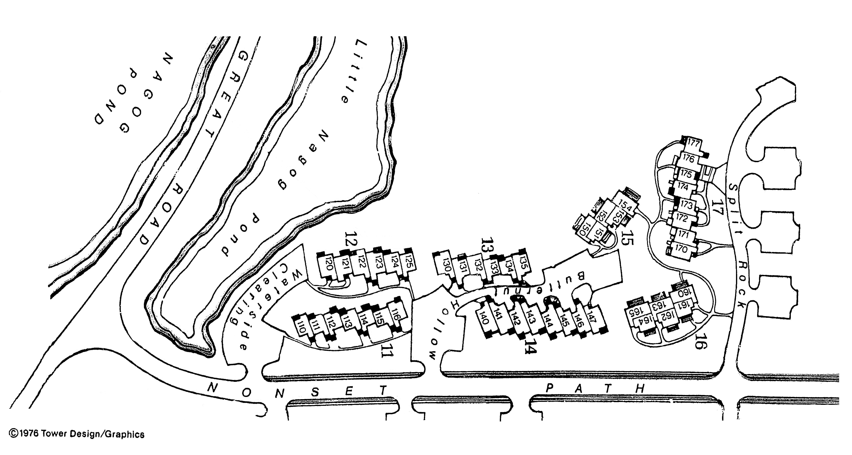
A
D
C
H
G
FF

E
B

Association II Parking
601 | E
602 | E
603 | E
604 | E
605 | D
606 | D
607 | D
611 | E
612 | E
613 | E
614 | E
615 | E
616 | E
621 | D
622 | D
623 | D
624 | C
625 | C
641 | B
642 | GAR
643 | GAR
644 | GAR
645 | GAR
646 | GAR
647 | GAR
648 | A
661 | A
662 | A
663 | A
664 | A
665 | A
666 | A
667 | A

Parking Area Map-Association II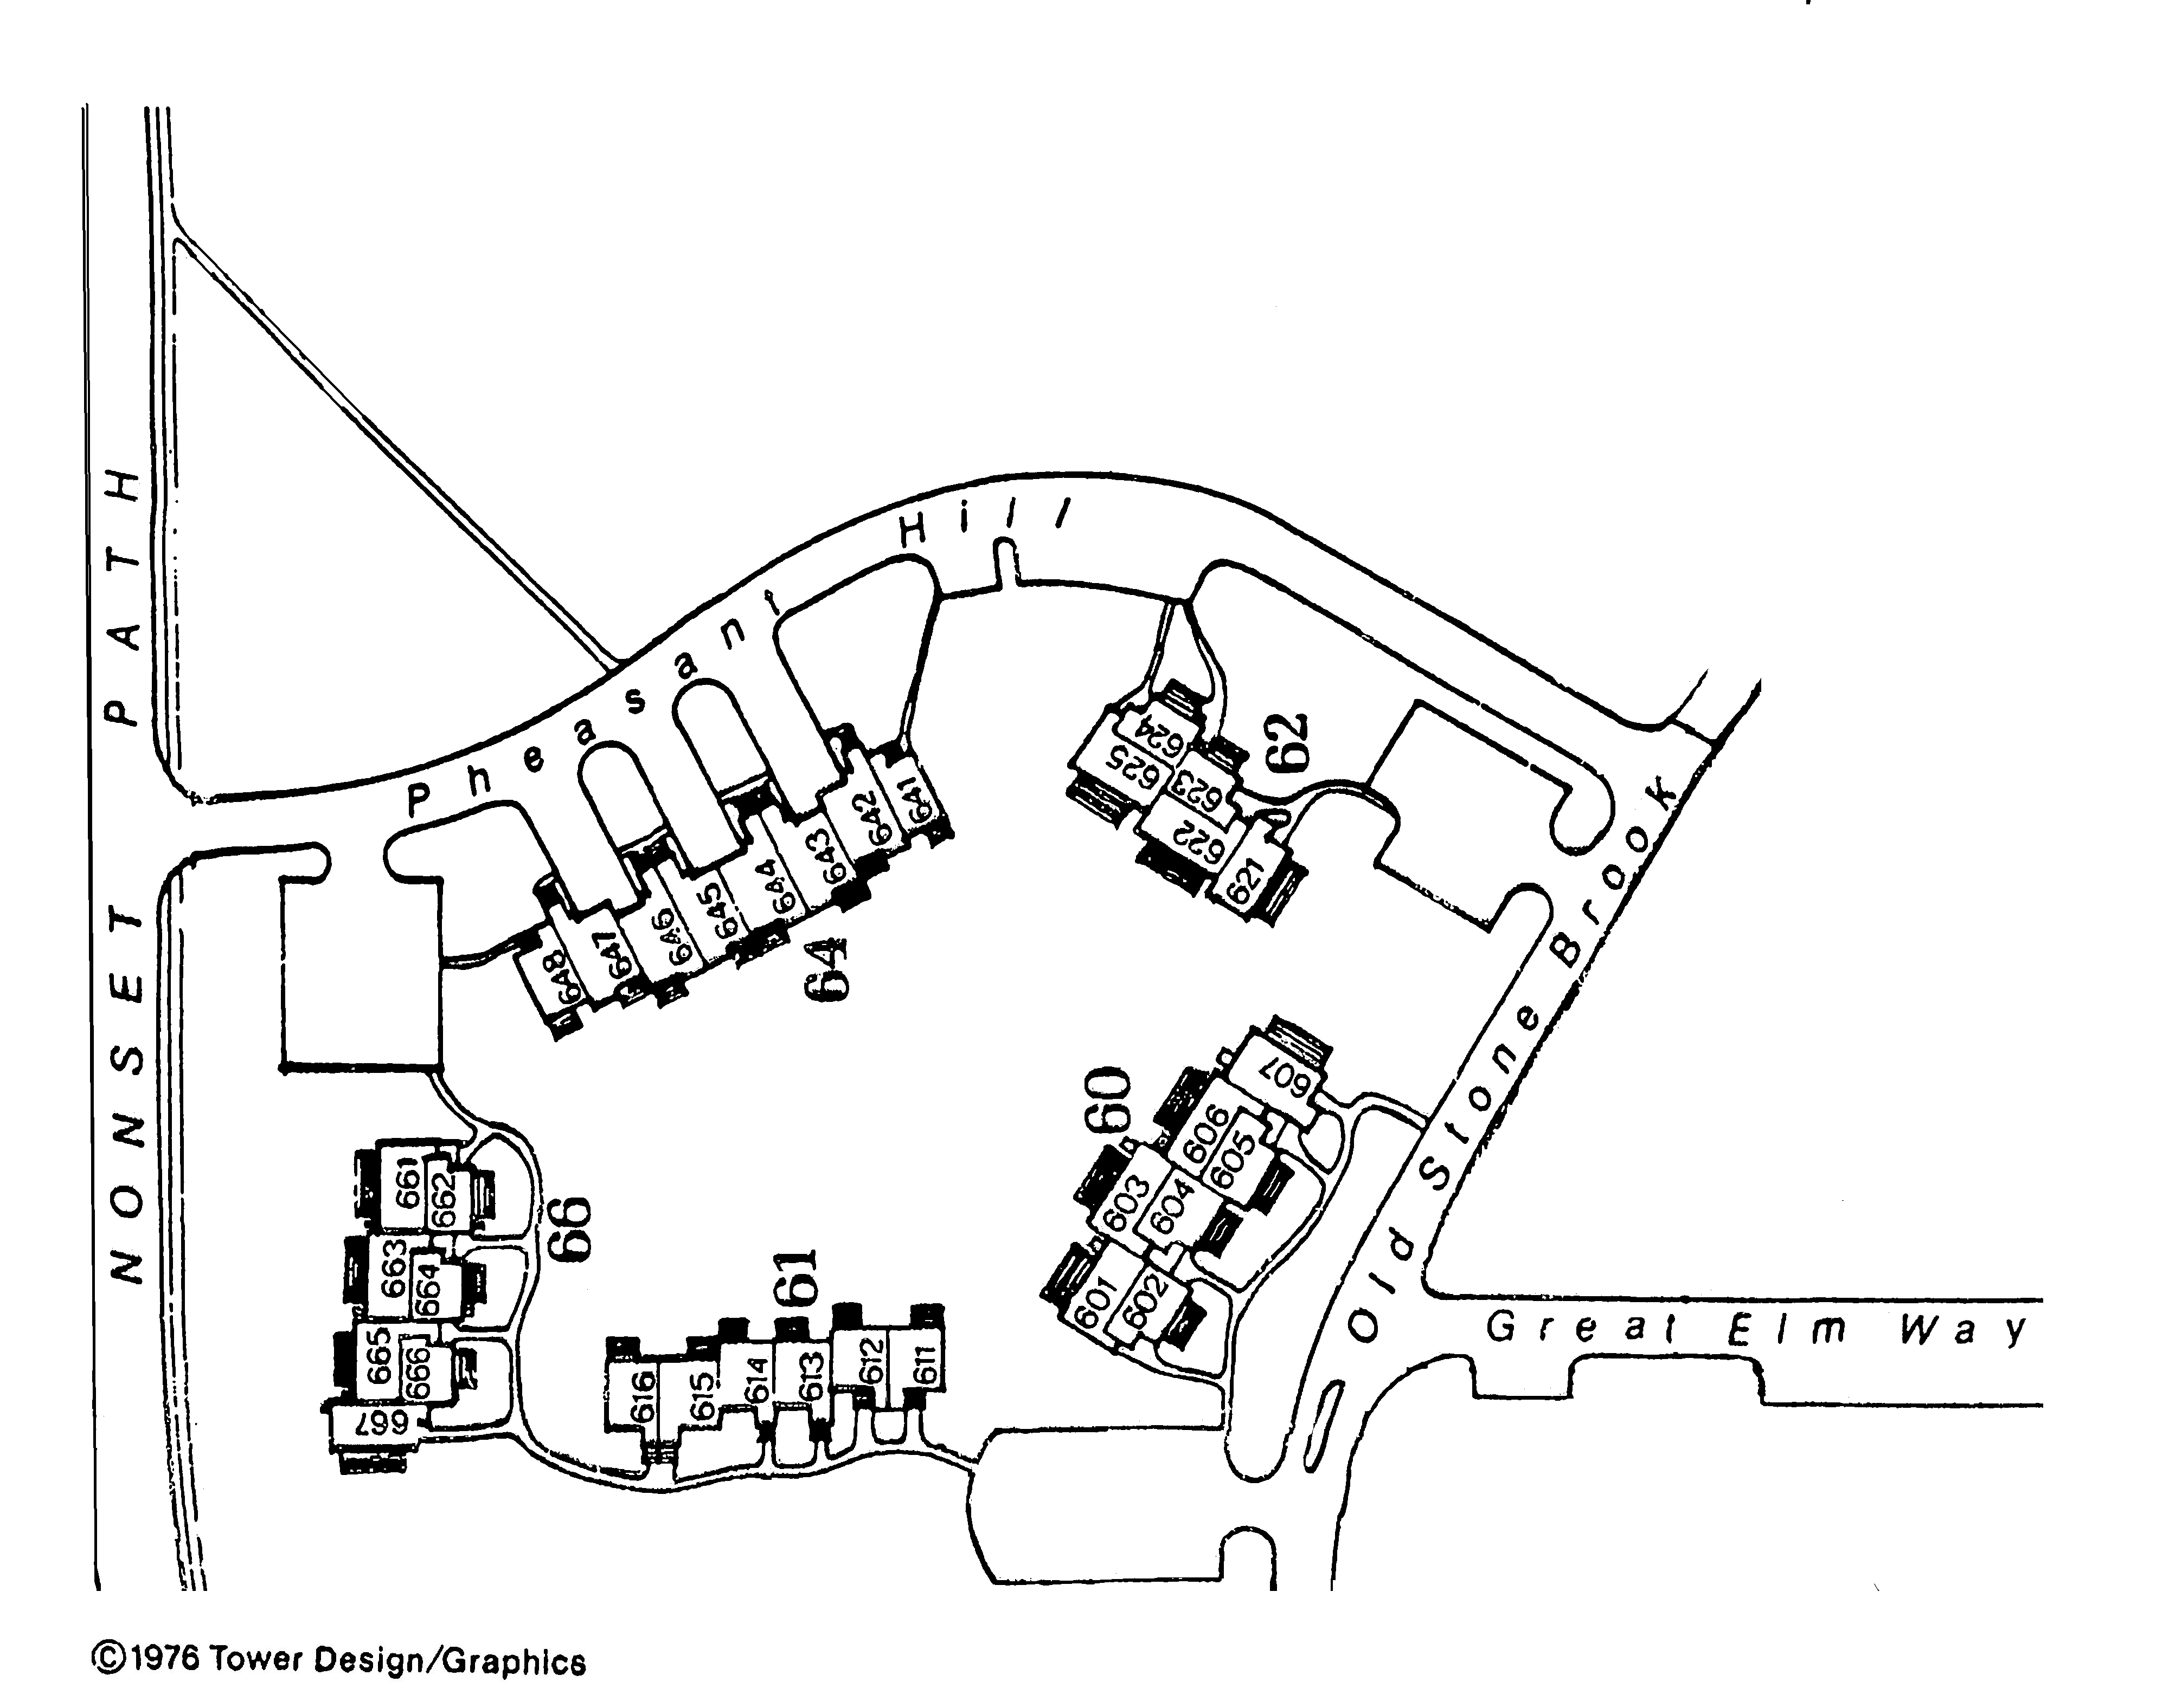
C
B
E
D
A

Association III
201 | MN
202 | MN
203 | MN
204 | MN
205 | MN
206 | MN
207 | MN
210 | MN
211 | GAR
212 | GAR
213 | GAR
214 | GAR
215 | GAR
216 | GAR
217 | MN
220 | L
221 | L
222 | L
223 | J
224 | J
225 | O
226 | O
227 | O
228 | O
229 | O
230 | K
231 | K
232 | H
233 | H
234 | H
235 | H
236 | H
237 | I
238 | I
239 | I
240 | J
241 | J
242 | J
243 | G
244 | G
245 | G
246 | G
247 | G
248 | G
249 | G
251 | I
252 | I
253 | I
254 | I
255 | I
256 | I
257 | I
501 | P
502 | P
503 | P
504 | PR
505 | PR
506 | O
507 | O
511 | R
512 | GAR
513 | GAR
514 | GAR
515 | GAR
516 | GAR
517 | GAR
518 | Q
520 | O
521 | O
522 | R
523 | R
524 | PR
525 | PR
526 | PR
527 | E
528 | E
529 | EF
531 | A
532 | A
533 | A
534 | A
535 | A
536 | A
537 | A
538 | A
539 | A
541 | A
542 | A
543 | TA
544 | BT
545 | BT
546 | BT
547 | BT
548 | C
549 | C
551 | D
552 | D
553 | D
554 | CD
555 | C
556 | C
557 | C
558 | A
559 | A
571 | CS
572 | CDS
573 | DS
574 | D
575 | CDS
576 | D
577 | CD
590 | F
591 | F
592 | G
593 | G
594 | G
595 | F
596 | EF
597 | EF
598 | E
599 | E

Parking Area Map-Association III
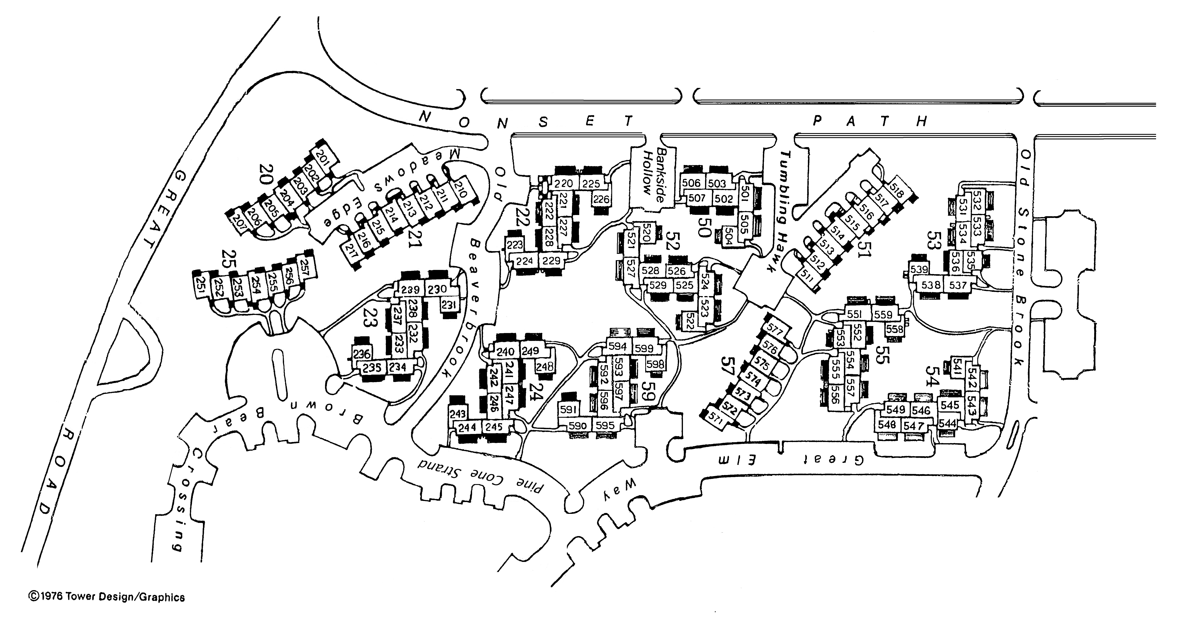
D
T
C
R
P
O
N
M
L
K
J
B
I
H
G
F
S
E
A
A

Association IV
261 | O
262 | GAR
263 | GAR
264 | GAR
265 | GAR
266 | P
271 | S
272 | GAR
273 | GAR
274 | R
275 | R
281 | R
282 | R
283 | K
284 | K
291 | M
292 | M
293 | M
294 | M
295 | N
296 | Q
297 | Q
301 | Q
302 | Q
303 | L
304 | L
305 | L
306 | K
307 | K
371 | J
372 | J
373 | GAR
374 | GAR
375 | GAR
376 | GAR
377 | GAR
378 | I
381 | I
382 | GAR
383 | GAR
384 | GAR
385 | GAR
386 | H
391 | F
392 | GAR
393 | GAR
394 | GAR
395 | GAR
396 | GAR
397 | G
398 | G
401 | F
402 | F
403 | GAR
404 | GAR
405 | GAR
406 | GAR
407 | GAR
408 | E
421 | AS
422 | GAR
423 | GAR
424 | GAR
425 | GAR
426 | B
431 | B
432 | B
433 | B
434 | D
435 | D
436 | D
441 | C
442 | C
443 | C
444 | D
445 | D
446 | D
Parking Area Association IV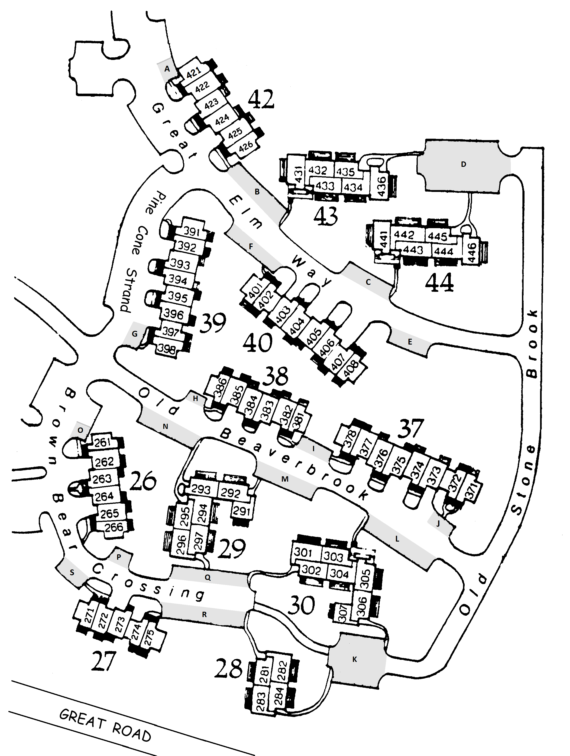

S

F

Amended Nagog Woods Condominium IV Parking Rules
October 16, 2013- As per Section 5 (b) of its Nagog Woods Condominium’s Master Deed, each Nagog Woods Association Board of Managers has the authority to specify the parking rules for its Nagog Woods Condominium.
The Nagog Woods Association IV Board of Managers has approved these parking rules for Nagog Woods Condominium IV:
- Each Unit in Nagog Woods Condominium IV is allowed two parking spaces. Unit parking has been assigned to a specific parking area according to the plan in Attachment A, but not to specific spaces within that area.
- The parking areas within Nagog Woods Condominium IV that are labeled A through S in Attachment B are restricted to the Units in Nagog Woods Condominium IV only.
- Units with garages and driveways must use their garages and driveways. These Units have no rights to any other parking area.
- None of the labeled parking areas that are depicted in Attachment B has assigned visitor parking spaces and none is designed as an overflow parking area. Residents who have more than two vehicles may park these extra vehicles in the Club House parking lot with the permission of the Community Manager.
- Parking for occasional guests is permitted according to the snow removal rules for Nagog Woods Condominium IV, but not overnight. Overnight guest parking is permitted in the Club House parking lot with the permission of the Community Manager. Residents may choose to move their vehicles to these designated areas to allow their guests to park in their Unit’s parking spaces.
- Residents may park in an area other than their assigned area for a maximum of 15 minutes for the purpose of loading or unloading groceries, luggage, goods, children, or for other reasonable purposes.
- The Handicapped and Medical Parking Guidelines as approved by the NWCC Board of Directors apply to all parking areas within Nagog Woods Condominium IV.
In accordance with the Village parking rules:
- Parking is limited to privately owned passenger cars, vans and pick-up trucks weighing less than 5,000 pounds. Other vehicles such as motor homes may be parked in the Club house parking lot with the permission of the Community Manager.
- Only registered and inspected motorized vehicles may be operated and parked within Nagog Woods Condominium IV.
- No unregistered or uninspected motorized vehicle may be stored in any residential parking areas. These vehicles may be stored at the Club House lot with the permission of the Community Manager. Storage time may not exceed 30 calendar days. Any vehicles stored in excess of that time will be towed and stored at an outside facility at the Unit Owner's expense.
- Parking is not permitted in fire lanes. Except for drop-off purposes and occasional guests, parking is not permitted on Nagog Woods Condominium IV roads.
- Residents and their guests are expected to follow the instructions contained in the snow removal plan that is issued by the Community Manager at the beginning of each snow season.
- Any resident not in compliance with these Nagog Woods Condominium IV Parking Rules will be subject the Village Parking Enforcement Rules.
Reporting Violations
- Residents should report any violations against the Nagog Woods Condominium IV and Village parking rules to the Community Manager or his designee.
- This violation report must include a description and/or the registration (license plate number) of the vehicle in violation.
- A log of these reports will be maintained by the Community Manager or his designee.
Village Parking Enforcement Rules & Appeals
The NWCC Board of Directors is responsible for enforcing the Village Parking Rules and the Nagog Woods Condominium IV Parking Rules in accordance with these Parking Enforcement Rules for the Village of Nagog Woods:
- 1st Offense: a warning will be issued.
- 2nd Offense: a fine of $25.00 will be assessed to the Unit Owner.
- 3rd Offense: the vehicle will be towed at the expense of the Unit Owner, including storage fees.
At each level, the NWCC Board of Directors or its designee will send a letter to the offender stating the violation and any action taken and any further action, if necessary, to bring the vehicle into compliance. The third offense letter will be sent by certified mail.
Residents may appeal an enforcement action, in writing to the Community Manager, and receive a hearing before the NWCC Board of Directors.
Residents may contact the Nagog Woods Association IV Board of Managers for information, petitions and requests via the Village Only Slot at the Postal Kiosk.

Clubhouse Parking Policy for Winter

If you are planning to be out of town for more than a few days please park your car at the Clubhouse. This will allow your parking lot to be cleared while you are away. You may park in the clubhouse parking lot for up to 10 days without written approval. After 10 days you will need written approval from Jim Shope, Community Manager.
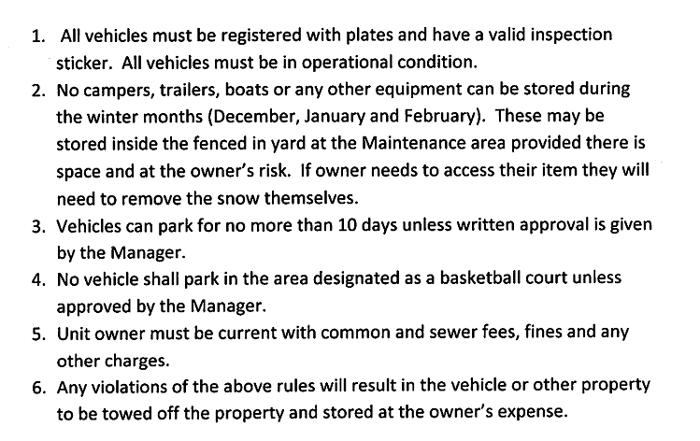

You will need to fill out and have the application approved prior to parking your vehicle. You will be assigned a parking space by the property manager and it will be noted on your application.

Approval Form for parking at the Clubhouse Lot
Nagog Woods Vehicle and Owner Information

Unit number #:________________________________________________
Unit Owner:___________________________________________________
Vehicle Owner:________________________________________________

Vehicle make:________________ model:___________________________
Is the vehicle registered:_______Yes ___________No
Plate number#:___________State__________

Contact Info
Phone number:________________Home_____________Cell_____________Work
E-mail________________________________________

When does the inspection sticker expire?_______________Date
Is the vehicle in operational condition?_________________Yes_________________No
How long will the vehicle be stored?_______________Start date___________End date

The vehicle owner acknowledges that they are parking at the Clubhouse Lot and the Village has no responsibility for any damages or to remove snow from around the vehicle.

Owner signature:____________________________________________Date______

Authorized by:______________________________________________Date______

NAGOG WOODS COMMUNITY CORPORATION

SATELLITE ANTENNA STANDARDS
Approved 4-25-01

These standards are adopted by the Board of Directors of Nagog Woods Community Corporation for the Village of Nagog Woods, on April 25, 2001, effective April 25, 2001.

WHEREAS, Nagog Woods Community Corporation (“Corporation”) is responsible for architectural control, safety and maintenance of the Village of Nagog Woods; and

WHEREAS, the Corporation exists pursuant to Mass. General Laws Chapter 180 and the Nagog Woods Community Corporation by-laws; and

WHEREAS, the Corporation is authorized to adopt and enforce rules and regulations in the interests of the Village of Nagog Woods, pursuant to Mass. General Laws, Chapter 183A, and the by-laws; and

WHEREAS, the Federal Communications Commission (“FCC”) adopted a rule effective October 14, 1996, and amended effective January 4 and 22 and February 16, 1999, preempting certain association restrictions on the installation, maintenance and use of direct broadcast satellite, television broadcast, and multipoint distribution service antennas (“Covered Antennas”); and

WHEREAS, the Corporation wishes to adopt reasonable standards governing installation, maintenance and use of antennas in the best interests of the Community and consistent with the FCC Over-the-Air-Reception Devices (“OTARD”) Rule;

NOW, THEREFORE, the Corporation adopts the following standards for the Community, which shall be binding upon all owners and residents and their grantees, lessees, tenants, occupants, successors, heirs, and assigns and which shall supersede any previously adopted rules on the same subject matter.

Satellite Standards con’t

Approved 4-25-01

Village Standards for satellite installations when unable to get acceptable signal from the inside of unit or exclusive use areas:

All satellite installations must be approved by the Village Manager for compliance.

Any side wall installation must be equal to or less than 2 feet above or below the roofline depending on the building. Any side wall installations must be approved by the Village Manager in advance.

No roof mounting will be allowed unless approved by the Village Manager prior to installation.

All mountings, hardware and covered antennas must withstand wind speeds up to 100 mph.

All cables must enter and exit through the unit at the nearest point of the mounting bracket.

All entry and exit areas must be sealed with a 30 year clear silicone sealant.

All cables and dishes are to be painted to match the exterior walls of the building.

The Village will not provide ladders, staging, or any other type of equipment, to residents or their contractors.

The Village is under no obligation to take any action to assist in satellite installation or ensure acceptable quality signal other then as explicitly provided herein.

Common Antennas:

If the Village installs a Central Antenna system which offers the same service from the same provider or from a different provider at an equal or lesser fee at any point in the future, the Village will require the removal of the antenna and reimburse the resident for the value of the antenna.

Satellite Standards con’t
Approved 4-25-01

Definitions:

- Antenna: any device used for the transmission and receipt of video or audio services, including Direct Broadcast Satellite (DBS), television broadcast, and Multipoint Distribution Service (MDS) a mast, cabling, supports, guy wires, conduits, wiring, fasteners, or other accessories necessary for the proper installation, maintenance, and use of a reception antenna shall be considered part of the antenna.
- Covered Antenna: subject to criteria detailed elsewhere in these rules, the following are covered antennas and may be installed: Antennas designed to receive Direct Broadcast Satellite (DBS) or Multipoint Distribution service (MDS) that are 39.4 inches (1meter) or less in diameter may be installed. Antennas designed to receive television broadcast signals, regardless of size. Transmission-Only Antennas that are necessary for the use of covered antennas. Masts that is required for the installation of covered antennas.
- Excluded Antenna: Any antennas larger than 1 meter are prohibited or subject to a prior approval process. All other Antennas (including amateur or ham radio antennas) not covered by the FCC’s OTARD rule as amended are prohibited or subject to the EQC process.
- Common Property: Any property not included within the unit but included within the Village of Nagog Woods.
- Exclusive-Use areas: Are areas designated in the By-laws that state the areas each unit has a right to use for their own personal use but does not own.

General Rules:
Residents may install Covered Antennas according to the following rules, provided that these rules do not unreasonably delay installation, maintenance, or use; unreasonably increase the cost of Covered Antennas installation, maintenance, or use; or preclude reception of acceptable-quality signals from Covered Antennas.

- Covered Antennas must be installed inside the unit whenever possible.
- Covered Antennas can be installed on Exclusive-Use Areas (decks, patios, and driveways). This does not convert these areas to individually owned property.
- Covered Antennas shall not encroach upon any Common Property, or any other Exclusive-Use areas, including airspace.
- Covered Antennas shall be located in a place shielded from view from other units, roads and walkways to the maximum extent possible. If covered antennas can receive acceptable-quality signal from more than one location, then Covered Antennas must be located in the least visible preferred location. This section does not permit installation on Common property, even if an acceptable-quality signal cannot be received from an Exclusive-Use area.

Satellite Standards con’t

Approved 4-25-01

- If an installation cannot comply with the previous section because the installation would unreasonably delay, unreasonably increase the cost, or preclude reception as acceptable-quality signals, the resident may install the Covered Antenna along the roofline provided it meets all approved Village Standards for installation and location, with prior approval by the Village Manager.

Installation:

- Covered Antennas shall be no larger or higher than is absolutely necessary for reception of an acceptable-quality signal. (See Definition section #b.)
- All installations shall be completed so that they do not materially damage any property in the Community including Exclusive-Use areas, or impair the integrity of any building in the Community.
- Residents are not required to hire a professional antenna installer unless it is above the roof. Any installation done by anyone other than a resident for his/her own unit shall be done by a qualified person to install the Covered Antenna, and shall provide an insurance certificate listing the Corporation as a named insured prior to installation. Insurance coverage must include general liability insurance in the amount of $1,000,000 including completed operations and workers compensation coverage.
- Covered Antennas must be secured so that they do not cause any property damage or personal injury to any person due to improper installation or from other forces including wind velocity of up to 100 mph.
- Residents are liable for any personal injury or damage occurring to any property or persons arising from installation, maintenance, or use of a Covered Antenna and accessories.
- Covered Antenna shall not obstruct access to or exit from any doorway, slider, walkway, driveway or ingress or egress of any utility valves, meters, or related equipment.
- All Covered Antennas must be effectively grounded.
- No more than one Covered Antenna providing the same service from the same provider may be installed.
- If the Covered Antenna is not being used or service has been discontinued, the antenna must be removed within 30 days.
- Any cost associated with removal and repairs to building will be born by the resident or owner as the case may be.
- If the Covered Antenna poses a safety hazard, the resident will have 72 hours after notice to make repairs or remove the antenna or related safety hazard. If the safety hazard remains after notification and the time allowed the Village will take necessary action and seek reimbursement from the resident and/or owner.

Snow Removal Rules approved 5-16-01

Over the years, many residents have not moved their cars in a timely manner after a snowstorm to allow efficient snow removal. When cars are not moved in a timely manner, the crew must continually circle the Village to remove snow from random areas. This is an expensive, time consuming problem. As a result, the Board has approved the following rules to facilitate snow removal.

Allotted Time:
Residents must move their cars within 4 hours of the storm ending (storm ending means no more accumulating snow). Exception if the storm stops during the night, you must move your car by 8:00 a.m.

Garages and Driveways:
All units with garages and driveways are to stay in those areas during snowstorms. Once the storm has ended those units must remove their vehicles from the driveways to designated road parking areas within the allotted time. Once the driveway is cleared all vehicles must be moved back within 4 hours.

Parking lots:
Residents should not move their vehicle(s) before an expected storm begins. Units that park in lots are to stay there until the storm is finished, unless you park in a designated snow removal area. These designated areas are usually areas where the snow is piled or needed to gain access to walkways (see maps for each Condo Association). These designated areas must be kept clear of cars until the lot is completely plowed. If you park in a designated area you must park along the Condo III side of Nonset Path or the Village side of Old Stonebrook in Condo IV. (Old Stonebrook parking is not allowed in Condo II and III). Once the storm ends all remaining vehicles in the lot must move within the allotted time to the designated road parking areas. Once the lot is cleared all cars must return to the lot within 4 hours.

General:
If you are going away you must leave your vehicle(s) at the Clubhouse or you must have someone move the vehicle(s) on your behalf. You are responsible if the vehicle(s) are not moved by that person and will be fined appropriately.

All vehicles must be off the roads within the allotted time of the parking areas being cleared.

No vehicles should be left on Nonset Path overnight during snow cleanup. Snow cleanup will not begin in parking lots and driveways if a storm ends during the night. Residents will have to move their vehicle(s) to their designated snow removal areas promptly by 8a.m. the day the storm ends.

Fines:
Any violation of the rules will be subject to fines of $25 per day per vehicle.
LANDSCAPE GUIDELINES
Adopted 5-19-04

GRASS AREAS

- Regular cutting during the growing season.
- Trimming and edging as necessary.
- Application of weed and feed chemicals as necessary.
- Thatching of all grassed areas and reseeding where necessary.
- Spring raking and cleanup of all areas.

TREES AND SHRUBS

- A tree whose trunk is 3 feet or less from a unit is deemed as “too close”.
- A tree that is “too close” will be tagged for removal by Nagog initiative with no unit owner appeal.
- Any tree that is too close, has rotted roots, serious disease, rotted trunk, or poses any danger will be removed with no appeal by residents.
- A tree whose trunk is between 3 feet and 6 feet from a unit will be removed at a unit owners’ request with no abutter input required. (Based on time and budgetary constraints).
- A tree whose trunk is more than 6 feet from a unit may be requested for removal through the existing EQC process.
- No trees or branches should overhang any roof line.
- Branches will be removed and trees up branched as necessary to minimize gutter cleaning, fire hazards, and to allow for air circulation between buildings and plantings.
- Regular pruning to control growth of trees and shrubs.

MULCH AREAS
- Application of bark mulch at a minimum of once every two years.
- To weed mulched areas at least twice a year.
- To deep edge mulch beds once every two years.
- To apply a pre-emergent weed control in early spring on large beds.
- To apply a post-emergent weed control as necessary.

GUIDELINES FOR FUTURE PLANTINGS

No trees or shrubs shall be planted any closer than 3 feet from a building, walk, road, parking lot, deck or patio measured from the plantings maximum growth drip edge.

No trees or shrubs will be allowed to block access to any courtyard.

No trees or shrubs will be allowed to cause the loss of any grassed area from the total blockage of sunlight.

SECTION 1: ARCHITECTURAL COMPLIANCE
PLEASE NOTE: In February 2010, the NWCC Board of Directors approved a list of standard exterior fixtures for use in replacement installations throughout the Village . Any replacement installation of front doors, storm doors, sliders, windows, skylights, door hardware, and unit outdoor lighting must use the fixtures specified on this list. View the Approved Replacement Parts List on the SenEarthCo website under the “Community Information/Property Information” tabs, or consult the Village Office.

- MAIN FRONT DOOR, STORM DOOR
  - NAGOG REGULATIONS: Front doors must be kept in good repair. It is the responsibility of the owner to maintain the front entry door and the storm door. Replacement storm and screen doors must conform to Nagog Standard Design.
  - RESOURCES:
1. You may stain a wooden door yourself with stain supplied by the Village Office.
- It is the Unit Owner’s responsibility to purchase and have installed front doors, replacement glass, screens, storm doors, and door hardware. Consult the approved Replacement Parts List on SenEarthCo, or contact the Village Office. Suppliers will recommend licensed, insured installers.
  - NONCOMPLIANCE INCLUDES:
- Nonstandard material and finish of front entry door or storm door
- Nonstandard material and finish of door hardware and door numbers
- Peeling or badly faded stain
- Badly scratched or delaminating wood
- Missing or obscured door numbers
- Temporary or permanent notices or signs posted on door
- Cracked, scratched, or missing plastic panes, glass panes and/or screens
- Rusted, discolored, or warped storm door
- Damaged, torn, or loose screens

- WINDOWS, SLIDERS, SCREENS, AND SKYLIGHTS
  - NAGOG REGULATIONS: Windows and sliders must be kept in good repair. It is the responsibility of the owner to maintain, repair, or replace the windows, sliders, and screens, as well as any storm windows or skylights. Replacement windows, screens, and skylights must conform to Nagog Standard Design.
  - RESOURCES: Consult the approved Replacement Parts List on SenEarthCo, or contact the Village Office. Suppliers will recommend licensed, insured installers.
  - NONCOMPLIANCE INCLUDES:
- Nonstandard material and finish.
- Fogged or broken windows or sliders.
- Damaged, torn, or loose screens, warped frames, or missing screens.

- EXTERIOR LIGHTING AND DOOR HARDWARE
  - nagog regulations: Exterior features such as entry and deck or patio lighting fixtures, front-door hardware, and vents must conform to Nagog Standard Design.
  - RESOURCES: . Consult the approved Replacement Parts List on SenEarthCo, or contact the Village Office. Suppliers will recommend licensed insured installers.

- OWNER-INSTALLED MODIFICATIONS
  - NAGOG REGULATIONS: Owners are responsible for maintenance of approved modifications. Deck stairs, gates, and railings which were NOT part of the original design and which were subsequently installed by any owner must be maintained and repaired by the current owner.
  - RESOURCES: TDG Maintenance Staff may assist owners with repair and staining. Contact the Village Office for schedule and cost information.
  - NONCOMPLIANCE INCLUDES:
- Deteriorating or damaged deck stairs and railings
- Deteriorating or damaged deck extensions

- CABLE / COMMUNICATIONS INSTALLATIONS
  - NAGOG REGULATIONS: Any exterior wiring must be done by the service provider and must adhere to Village standards.
  - RESOURCES: Contact Comcast Customer Service at 1-800-266-2278 for installations or repairs. Contact Verizon at 1-800-837-4966 for FiOS and telephone installations or repairs.
  - NONCOMPLIANCE INCLUDES:
- Owner-modified installations, including wires entering unit at unauthorized locations.
- Illegally spliced cables.
- Unauthorized cable TV or communications installations.

- eqc modification request procedure
  - NAGOG REGULATIONS: No alterations, additions, or modifications (including but not limited to decorations) may be made outside any unit, including both grounds and buildings, without prior written approval of the Board of Directors, via the EQC Modification Request procedure.
  - RESOURCES:
- Residents wishing to introduce exterior modifications must submit an EQC Modification Request. The review process ensures that the items conform in construction, appearance, quality, and safety to accepted Nagog standards. The abutters, Village Management, EQC, and the Board need to review the request. The Board and EQC will approve or deny modification requests. Approved modification requests on record preserves the legitimacy of Nagog Regulations.
- EQC Modification Request forms are available from the Village Office and are also available for download from the SenEarthCo website. Complete the form as described in the instructions. Consult the Village Manager or EQC Chair for assistance if necessary.
  - SEASONAL ITEMS SUBJECT TO EQC MODIFICATION REQUEST APPROVAL PROCEDURE:
    - Patio Screen House -- Annual Approval Required: A Nagog standard has been developed for patio screen houses, with a specific size, design, and color. The EQC Modification Request procedure must be followed to ensure abutter input and appropriate installation.
    - Mosquito Magnets↓ or similar devices -- Annual Approval Required: An EQC Modification Request is required to ensure abutter input and appropriate installation. These devices are placed on common areas, yet the benefits accrue to an individual unit. Mosquito Magnets are seasonal equipment. They may be operated during the mosquito-breeding season (May to October) and must be removed from the common area at other times. NOTE: Electric bug-zappers are prohibited in the Village.
- noncompliant ITEMS INCLUDE, BUT ARE NOT LIMITED TO, THE FOLLOWING EXAMPLES:
  - Exterior modifications done without EQC and Board approval.
  - Unauthorized alteration of common areas, for example, a brick or stone patio or patio extension, walkway edging, garden fencing, flagstones, or decorative stepping stones delineating a path across grassed areas.
  - Any item placed such that interferes with regular maintenance of the common area.
  - A nonstandard exterior feature.
  - Anything that defeats the integrity of the structure, for example, any feature that requires drilling through an outside wall into the interior of the unit, such as unauthorized cable, communications, or antenna installations.
  - Decorative items, including but not limited to:
- Carpet or rug on decks or patios
- Exterior shades or blinds, for example on an upper-story balcony
- Garden statuary, birdbaths, sundials, or any similar item placed in common areas such that it interferes with regular maintenance of the common area.
  - Large outdoor toys or play structures placed on decks, patios, or common areas.
NOTE: The Village maintains a Tot Lot, designated play areas, a soccer field, and the toddlers’ pool adjacent to the main pool. There are also tennis courts and a basketball hoop with quarter-court markings at the Clubhouse. These resources are provided for the use of residents and eliminate the need for any individual children’s sandboxes, wading pools, soccer or hockey nets, basketball hoops, and similar structures. Children’s toys must be stored indoors when not in use.

- NONCOMPLIANCE: SAFETY
Any item that would impair residents’ safety, impair the integrity of structures, or negatively affect Nagog’s liability or insurability is not permitted in the Village because of safety considerations.

- THE FOLLOWING ITEMS ARE PERMITTED WITHOUT EQC OR BOARD OF DIRECTORS’ APPROVAL, AS LONG AS RESIDENTS STAY WITHIN THE GUIDELINES NOTED BELOW:
  - Satellite antennas: Antennas may be installed provided they conform in all respects to the Nagog Satellite Antenna Installation Standards, dated April 25, 2001.
  - Door peepholes.
  - Door locks: Provided they follow Nagog Standard Design.
  - Winter Holiday wreaths or sprays: Provided they are no larger than 30 inches in diameter.
NOTE: No other exterior Holiday decorations are permitted.
  - Exterior thermometers: Thermometers should be unobtrusive. Color should be subdued to complement the colors of the buildings. Thermometers may be attached to or installed in exclusive-use areas only and not the common areas, including on trees or shrubs.
  - Birdfeeders: Birdfeeders should be clear plastic, glass, metal, or wood. Color should be subdued. Birdfeeders may be attached to or installed in exclusive-use areas. However, if abutters have no objection, a pole-mounted birdfeeder may be installed in a mulched common area.
  - Hanging planters: Colors should be subdued hanging planters are intended to contain seasonal flowers or plants. They must be removed if empty or when the plant dies. Hooks for hanging planters may be mounted on the vertical wooden surface between sliders, attached to the deck railing, attached to the trim board adjacent to a front door, or from an overhanging roof at an entryway. Hooks may not be affixed to clapboards, brick, trees, or shrubs.
  - Plant containers and flowerboxes for patios and decks: Containers, pots, and flowerboxes should be of subdued colors to complement the colors of the buildings.
  - Wind chimes: There is a limit of one wind chime per unit, with a maximum size 18” by 18” by 18.” Wind chimes may be attached to or installed in exclusive-use areas only and not the common areas, including on trees or shrubs. Noise created shall not be loud enough to be a nuisance or to disturb a neighbor.
NOTE: No other hanging exterior decorations are permitted.
  - Deck rail space enclosure. To prevent children from falling, the space between the deck rails may be enclosed with 1” by 2” rectangular welded wire mesh. The mesh must be galvanized steel, painted dark green or brown, and secured to the inside of the rails facing the unit. It shall not extend above the top rail or below the deck. NOTE: The space between the upper-story deck rails is enclosed with wire mesh to comply with property insurance regulations. The unit owner must not remove the mesh installed on these upper-story decks.
  - American Flag and flag holder: A flagpole holder, for a pole of less than 1¼” diameter, may be left in place if subdued in color and location. The size and location of a flag should not unduly obstruct a neighbor’s view. One American lag per unit is permitted. The Flag must be in good condition and properly displayed.
  - Entry mats: Mats must be located immediately adjacent to a unit entrance. They shall not be placed on vertical surfaces like stair risers. Entry mats may be tan, dark brown, gray, or black. Entry mats must be in good condition.
  - Outdoor furniture covers: Deck and patio furniture that cannot be stored indoors may be covered if required to protect the furniture during inclement weather. The covers must be designed for furniture, and must be a plain, subdued color, for example, tan, gray, brown, dark green, or black. Tarps are not permitted.
  - Market-style umbrellas: Must be a solid color.
  - Grill covers: Grill covers made for the specific brand or designed to cover grills may be used to protect grills. The covers must be a plain, subdued color, for example, tan, gray, brown, dark green, or black. Tarps are not permitted.
  - Fire Pits: These are not allowed in the Village due to potential fires they may cause.
  - Outdoor Lighting: No additional outdoor patio or deck lighting is allowed due to safety and fire hazards.
  - Propane tanks for gas grills: Two propane tanks per unit are allowed, stored with the grill on a patio or deck. Two propane tanks means having one attached to the grill for current use and one additional tank. Propane tanks must not be stored under decks.
  - Grills: Gas and charcoal grills can be used for cooking only and must be 10 feet away from buildings and structures (units, fences, eaves, etc). Grills may not be used under decks or overhangs, they must be moved. Grills should never be used on upper decks, only at ground level or on patios. The only grill that may be used on an upper deck is one that is connected to a natural gas line that has been installed and inspected by the Town of Acton. Residents should always use appropriate safety and wait to move grills back to patios for storage until they have completely cooled down after cooking. Residents should also not keep grills up against or directly next to units. These requirements are a MA Fire Code Regulation and an insurance requirement. All grills must be in good condition.
SECTION 2: STORAGE STANDARDS
- NAGOG STORAGE REGULATIONS (Nagog Woods Restrictions): Each unit owner is responsible for maintaining unit property in good condition. Decks and patios shall be kept neat and clean, and shall not be used for storage; this rule is not intended to prevent their intended use.
No clothes, sheets, blankets, laundry, towels, or any other articles shall be hung out of a unit or on any part of the common elements or community areas. Clotheslines are not allowed in the Village.
There shall be no obstruction of the common elements or community areas, nor shall anything be stored (do not store items by the front door) therein except in areas designated as storage by the Board of Directors, where such storage shall be at the resident’s risk. Since decks and patios are highly visible, storage of personal property (for example, automobile tires) is not allowed on decks or patios.
  - RESOURCES:
1. TDG Maintenance Staff will help if you need assistance discarding multiple items or large items. Submit Work Requests online from the SenEarthCo website (through www.TheDartmouthGroup.com) or through the Village Office. NOTE: A disposal fee will be charged.
2. Hazardous waste materials, including computer monitors, may be disposed of during Acton’s Hazardous Waste Days. Contact the Acton Board of Health (978-264-9634) for dates and information.
  - BICYCLES: Bicycles may be stored outdoors, upright on a patio or rear deck, during the bike-riding season (March through November). Small bike racks and stands, such as those available at Pedal Power (Great Rd., Acton, MA) may be used to keep bicycles upright. Bicycle covers in subdued colors such as black, dark gray, or dark brown may be used; tarps are not permitted in Nagog. Residents wishing to have a means to secure bikes on patios may install an eyebolt in the wooden patio edging through which a cable can be looped to lock the bike.
  - PATIO AND DECK STORAGE BOXES: In 2006, the Board of Directors approved a product available from benches.com, the “Cedar Stowaway Bench” (or its substantial equivalent). The bench is intended for use on decks and patios, to store cushions, toys, grilling gear, and gardening equipment. The approved product is constructed of cedar, which is weather, mold, and rot resistant. The Board and Village Manager reserve the right to determine whether substantially equivalent storage products are safe and appropriate for Village use. Storage boxes should be fitted with child-safe lid supports to prevent accidental closure (for example, see www.rockler.com “toy box lid supports.”)
  - NONCOMPLIANCE INCLUDES EXTERIOR STORAGE OF items such as, BUT not limited to, the following examples:
    - Any item deemed a hazard to residents’ safety or health
    - Flammables, combustibles, or explosives, except those that are normally kept in residences
    - Items obstructing common walkways and posing a safety hazard
    - Screens or storm windows stored on patios, decks, or common areas
    - Clothes, sheets, blankets, laundry, towels, or any other articles hung out of a unit or on any part of the common elements or community areas; clotheslines
    - Sports equipment
    - Out-of-season tools and equipment
    - Out-of-season decorations
    - Obviously broken, unusable, or surplus seasonal items (for example: broken or badly deteriorated plant pots, dilapidated outdoor furniture, broken grills, rusty bicycles)
    - Trash receptacles of any kind; trash bags
    - Items saved for recycling, including paper, glass bottles, and cans
    - Discarded remodeling supplies
    - Tarps covering bicycles, furniture, equipment, or firewood
- FIREWOOD STORAGE

NAGOG REGULATIONS: Firewood must be stacked neatly on or under decks, or on patios, subject to the following: Wood must be stored at least 6 inches away from the building to prevent problems with carpenter ants and termites. Wood must be stacked on pressure-treated 2”x4”s or other suitable means. Wood may not be covered by tarps. One-quarter of a cord is the maximum amount that may be on a deck. Units having a private-use easement (some courtyards) may use those areas provided the wood is stacked complies with the above conditions.

RESOURCES: TDG Maintenance Staff will remove unwanted or rotted firewood. Submit Work Requests online from the SenEarthCo website (through www.TheDartmouthGroup.com) or through the Village Office.

NONCOMPLIANCE INCLUDES:
- Excessive amount of firewood stored on deck (structural hazard)
- Rusted or broken firewood holder
- Messy woodpile
- Rotting firewood
- Tarp covering wood
RESOURCES
Nagog Office:
Telephone: 978-263-4887
Monday through Friday, 7:30 AM to 4:00 PM
An answering service takes your call after business hours and on weekends. In the event of a maintenance emergency, the answering service will page a Maintenance Staff Member. You must give your phone number and unit number to the answering service operator if you wish to have Maintenance respond to your call.
>> RESIDENTS MUST CALL 9-1-1 TO REPORT A FIRE, POLICE, OR MEDICAL EMERGENCY.
PROPERTY MANAGEMENT COMPANY:
The Dartmouth Group
4 Preston Court, Suite 101
Bedford, MA
Telephone: 781-275-5842
NAGOG WOODS Website: the SenEarthCo system allows owners to view and manage their account, submit work requests, view meeting agendas, read meeting minutes and reference the condo documents, including Bylaws, Master Deed, and Restrictions. A calendar of events shows scheduled Board meetings and dates the Clubhouse is reserved for private functions. Access SenEarthCo as follows:
- Go to The Dartmouth Group website, www.TheDartmouthGroup.com
- Click the header, “Access your personal online account and association’s website here”
- Sign in, using your email address as User Name, and the password you selected when creating your account

MASTER WATER SHUT OFF LOCATIONS

Condo I Building numbers 11, 12, 13, 14, 15,16, & 17
Master shut off for Building # 11 for units 110,111, and 112 is located in the crawl space under unit 110 on the back wall. There is also a gate valve behind unit 110.

For units 113, 114, 115, and 116 the shut off is located in the crawl space under 116 on back wall. There is a gate valve behind unit 116.

Individual shut offs are located in the closet of back bedroom downstairs and has a yellow handle.

Master shut off for Building #12 for units 120,121,122, and 123 are located in crawl space under unit123 at front of the unit. Master shut off for units 124 and 125 are located in the crawl space under unit 125.

Individual shut offs are located in laundry closet or front bedroom closet.

Building #13 master shut off for building must be done at water pit located in 1st parking lot on right of Butternut Hollow. Individual shut offs are located in the front bedroom closets.

Building #14 Master shut off located in water pit in 1" lot on right in Butternut Hollow. Individual unit shut offs are located under front landing.

Building #15 master shut off is located in the water meter pit located in 1" right parking lot in Butternut Hollow. Individual shut offs for 150 & 151 are located in unit 151. Unit 152, 153, and 154 have individual shut offs located in their own basements.

Building #16 master shut off is in the water pit located between buildings 16 & 17. The individual shut offs are located in the laundry closet under the stairway.

Building #17 master shut off is located in water pit between buildings 16 & 17. Individual shut offs are located in the basement back walls.

CONDO II
Condo II Building #60, 61, 62, 64, and 66.

Building 60 master shut off is in unit 601 for units 601,602,603, and 604. The gate valve is located outside unit 601 facing parking lot. The individual shut off is over the hot water heater in the basement.

Units 605,606 and 607 master shut off is located in the basement of 606 near water heater. Individual shut offs are located above hot water heater in basements.
Building # 62 the master shut off is located in the basement of #621. The individual shut offs are located over the hot water tanks.

Building #64 there are three main shut offs located in the basement of #641. Individual shut offs are located in the laundry room. The shut off for #648 is located behind a wall panel in the front closet near the hot water tank.

Building #66 there are two shut offs located in the basement of #661. Individual shut offs are located over the hot water tanks.
CONDO III
Building # 53 the main is located in the basement of #535 with unit shut offs located near hot water tank.24

Building #54 has two mains and one is located in the entrance closet and controls Units #541-545. Units #546-549 are controlled from #549 entrance closet. Unit shut offs are in the laundry closet. There is a water meter pit located in the lawn and is between building #53 & #54 by Old Stonebrook that will shut off both buildings.

Building #55 the water main is located in #553 basement.

Building #57 the main is located in Unit #575 under the front stairs.

Building #59 the main is located in Unit #592 laundry closet.

Building #51 the main is located in Unit #514 on back wall of basement.

Building #50 the main is located in Unit #502 by the hot water heater.

Building #52 the main is located in Unit #528.

Building #20 the main is located in Unit #202 under the front stairs.

Building #21 the main is located in the basement of Unit #213 on the back wall.

Building #22 the main is located in Unit #221 in basement by the bulkhead.

Building #23 the main is located in Unit #237 in basement by the bulkhead.

Building #24 the main is located in Unit #247 in the basement by the bulkhead.

Building #25 the main is located in Unit #257 under front stairs.

CONDO IV

Building #26 the main shut off is located in Unit #264 under the stair landing.

Building #27 the main shut off is located in Unit #273 under the stair landing.

Building #28 the main shut off is located in #283 utility closet.

Building #29 the main shut off is located in #296 utility closet.

Building #30 the main shut off is located in the basement of #301.

Building #37 the main shut off is located under the stair landing in Unit #376.

Building #38 the main shut off is located under the stair landing in Unit #384.

Building #39 the main shut off is located under the stair landing in Unit #394.

Building #40 the main shut off is located in the master bedroom closet of #401.

Building #42 the main shut off is located under the stair landing of Unit #425.

Building #43 the main shut off is located in the basement of Unit #434.

Building #44 the main shut off is located in the basement of Unit #442.

HANDICAPPED/MEDICAL PARKING GUIDELINES
The Board of Directors has agreed upon the following guidelines for the approval of medically necessary and disabled parking. The establishment of these guidelines is in response to an increase in resident requests to park close to the entrance of their unit due to medical necessity or disability.

1. Any resident requesting designated handicapped parking who has been issued a
"Handicapped" plate or placard by the Commonwealth of Massachusetts will have this request automatically honored as long as the handicapped plate or placard remains on the vehicle. Documentation of such a plate or placard must be provided by the resident to the Village Manager. Upon submission of such documentation, the Village Manager will be able to authorize these spaces without any additional input from the Board. No handicapped parking space will be designated without the resident making a specific request.

2. Ongoing documentation of a handicapped plate or placard must be submitted to the office in conjunction with the renewal of the plate or placard by the Commonwealth of Massachusetts.

3. Such designated handicapped parking spaces will be marked with an official blue sign with the handicapped logo.

4. Any resident requesting designated medical parking will be required to submit
documentation from their physician stating the reason for medically required parking and the expected duration of the need. Upon submission of such documentation, the Village Manager will be able to authorize a designated medical parking space for a maximum of three months without any additional input from the Board.

5. Residents requiring medical parking for longer than three months must resubmit
appropriate documentation before an extension can be granted. Requests for such
extensions will be reviewed and approved by the Board of Directors. Renewals will be granted for no longer than 3 months at a time.

6. Approved medical parking will be marked with a sign (in compliance with Village
Signage rules) identifying the space as "Medical Parking - Temporary Authorization."
Such signs will be removed when documentation expires and is not renewed.

Responsibility Chart for Nagog Woods

Item Unit Owner NWCC Other
Appliances X

Interior alterations X
Exterior modifications (adding stairs to your own unit) X X

Exterior modifications (walkways) X X

Trash collection (no Hazardous waste, ie: chemicals, X
TV's, computer monitors, oil paint, anti-freeze, car oil,

Exterior pest control X

Interior pest control X

Plumbing (serving your own unit including
shut-off valves) X

Plumbing (serving more than one unit) X X

Sewer drain pipes (serving your unit) X

Sewer drain pipes (serving more than one unit) X

Air conditioner & condensing unit X

All windows, doors & screens (including storm doors) X

Water & sewer treatment X X

Exterior maintenance and repairs X

Snow removal X

Insurance for units ($25,000 deductable/owner) X

Personal property insurance (reommendedw/Nagog policy) X

Electrical affecting only your unit X
Electrical servicing your unit outside X X

Landscaping and mowing X

Outside lights controlled by you (ie: patio/ front door) X
Outside lights controlled by Nagog X

Village Map

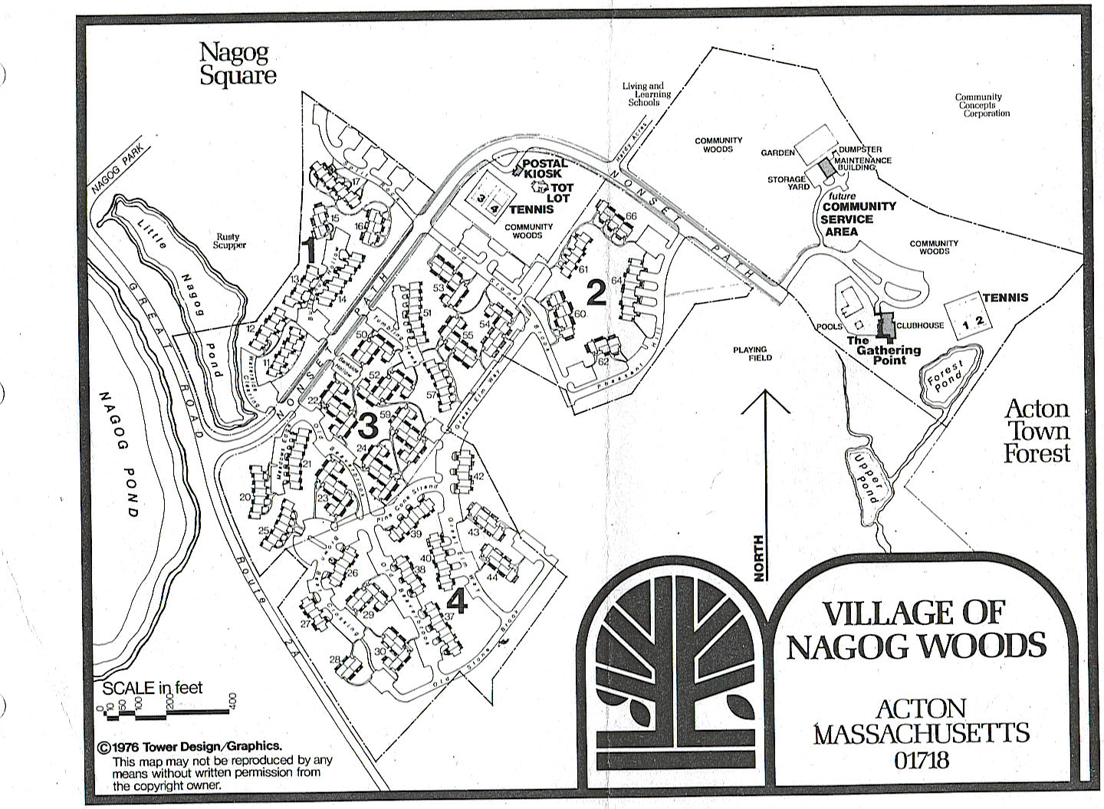

NAGOG WOODS COMMUNITY CORPORATION

VILLAGE OF NAGOG WOODS
ACTON, MASSACHUSETTS 01718
(978) 263-4887 FAX 978-263-8063

Closing Documents Needed for Sales

You will need a 6 (d) Certificate and an Architectural Compliance Certificate. The documentation fee is $100 for these two documents. The documentation fee must be paid before receiving the documents. You must give the office 10 days written notice but not less than 3 days of the closing date of when you would like to pick up the 6(d) certificate.

In order to issue a clean 6(d) for a sale or refinance of a unit all sewer fees and account balances must be paid to date.

You must provide the name of the person purchasing the unit and the date of the closing.

Sewer Fees for Sales and Refinances
The Owner must contact the Acton Water District at 978-263-9107 to arrange to have their water meter read on the day before the closing. Once the Water Department reads the meter they will issue you a final bill indicating the number of cubic feet used from the previous reading. You must then bring your final bill to the Nagog Woods office. The office will then calculate the sewer charge based on that usage with the then current per cubic feet sewer fee plus and $5.00 administrative fee. This sewer charge must be paid in full before a clean 6(d) certificate can be released. There is no guarantee that you will receive the 6(d) the same day you make the sewer payment. We must review accounts and get the 6 (d) certificate prepared and notarized. Please make an appointment for pick up time.

Certificate of Acknowledgement
This document will confirm the acknowledgement of condo, water, and sewer fees, as well as important rules and regulations. The certificate must be signed by both buyer and seller before release of 6 (d) Certificate.

The Architectural Compliance and Acknowledgement Certificates will be emailed together.

Architectural Compliance
Appointment must be made with the Village Office. Items in non-compliance will be documented and notarized. This certificate must be signed by seller and buyer before release of 6(d) Certificate.

Insurance Information for Binders
The information should include the name of the unit owner, address, loan number, mortgage clause and a phone number with contact. Forward the request to HUB International: condocerts@hubinternational.com
You may also call Courtney Tozier at 800-370-0642 and the policy number is #PHPK1556262. FAX- 866-475-7959
Appendix B

Policy for POD/Storage/Shipping Containers/Dumpsters

Guidelines for Moving in or out of the Nagog Woods using “PODS”/Storage/Shipping Container/Dumpsters

- Will be permitted for no longer than 3 days with prior approval by the manager. Please call the Nagog office for permission and approved location before having the container delivered.

- If the container exceeds the 3 day limit, it will be removed at the
Owner’s expense.

- A $100 damage deposit must be received before the container or dumpster is delivered to the Village.

- The container or dumpster will be allowed, only in the Resident’s driveway or parking space, and cannot impede other Residents access to their driveway, garage or unit.

- Are not permitted to be placed on the street.

- The manager reserves the right to inspect the property after removal. The Owner will be billed for any damages resulting from the container or dumpster. Please call the management office after removal of the container so that we can inspection the area. If there is damage, the Association will have the repairs made and use your deposit for this repair. If the damage is in excess of the $100.00 deposit you will be billed for the extra cost. Once the inspection is completed and there is no damage the deposit will be returned.

I accept these terms:

______________________ ______________________
Signature Date Signature Date

__________________________
James Shope, Jr., Village Manager
Village of Nagog Woods
By: The Dartmouth Group, Inc., its Managing Agent

Nagog Woods Community Corporation
This form must be returned to 100 Nonset Path, Acton, MA 01718
Office: 978-263-4887
*** EMERGENCY NOTIFICATION FORM ***

Unit Address:

Date of Purchase of Unit:

NAMES OF ALL PERSONS (1)
LISTED ON DEED:
(2)

(1) Tel #: (Home) Tel #: (Work) Tel #: (Cell)__________________

(2) Tel #: (Home) Tel #: (Work) Tel #: (Cell)__________________

E-MAIL ADDRESS:
PLEASE PRINT CAREFULLY

Mailing Address of Persons listed on deed (if different from unit address):

Street:

City: State: Zip:

EMERGENCY CONTACT/AGENT:

Name:

Street: Tel #: (Home)

City: State: Zip: Tel #: (Work)

Is this person authorized to order maintenance/repairs? Yes No

UNIT OCCUPANT INFORMATION (OWNER OR TENANT, AS APPLICABLE):

Occupant Name(s): _______________________________________________________________________

IF UNIT IS LEASED, PLEASE COMPLETE ADDITIONAL TENANT INFORMATION:

Tenant Telephone: (Home) (Work)

Lease Expiration Date: _________________________ (Copy of lease should be attached, as stated in the Condominium Documents)

Is tenant authorized to order maintenance/repairs? Yes No

PLEASE COMPLETE THE FOLLOWING:

Vehicle Information Vehicle #1 Vehicle #2
Make/Model
Color/Year
License Plate #

Pet Information
Brief Description:

I have received a copy of the Nagog Woods Community Corporation Rules and Regulations.
(If not, please contact jlambros@thedartmouthgroup.com ) (Initial Here)

Signature of Unit Owner Date

Signature of Unit Owner Date

MORTGAGE AND TENANT INFORMATION REQUIRED PURSUANT TO
CHAPTER 400 OF THE ACTS OF 1992
This form must be returned to The Dartmouth Group

Unit Address:
Unit Owner(s) Name(s):
Mailing Address:
City/State/Zip:

First Mortgagee
Bank/Lender Name:
Mailing Address:
City/State/Zip:
Loan or Account Number:

Second Mortgagee
Bank/Lender Nam:
Mailing Address:
City/State/Zip:
Loan or Account Number:

Any Other Mortgagee
Bank/Lender Name:
Mailing Address:
City/State/Zip:
Loan or Account Number:

Investor unit owners must also provide the following information:

Tenant Name(s):
Phone Number:

